Detail Step by step procedure to find out performance of Server

Daily Report
1. Avg. Dialog Response time [8-9am] in ms
Tcode ST03 → application -→performance database-→today--→dialog-→time profile
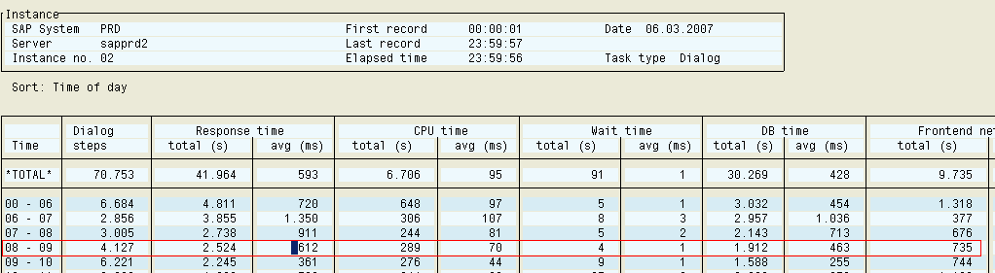

2.
% Dia Resp.Time <.5 | % Dia Resp.Time <10

Tcode ST03N→Load distribution→ instance comparison→compare periods then
hit on >> (Summary of response time distribution)
manually calculate all the response time first between <0.1 to < 0.5 and then calculate <0.1 to < 10

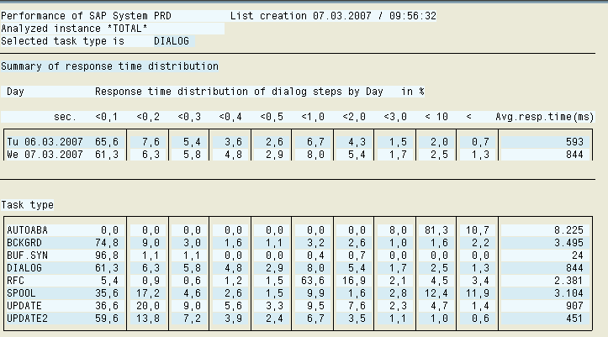

3. CPU
Load Avg. | User % | System % | Idle %
Go to Tcode ST06-→ performance database (compare resent days)

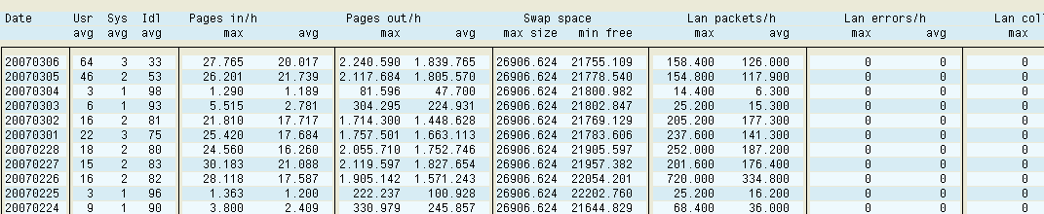

4. Weekly Report

Avg. Dialog Response time [8-9am] in ms per week

Tcode ST03 → application -→performance database-Previous week---Dialog→ time profile

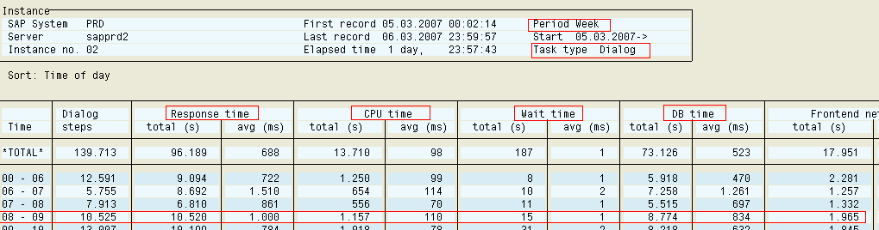

5. Monthly Report
 | Database Size MB | DB free MB
Tcode DB02 -→ space history ---monthly

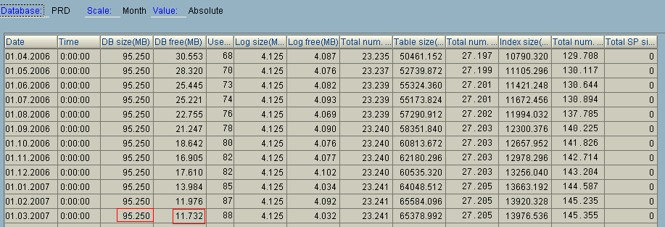

6.ERP 20 Largest Tables
Tcode DB02→DB analysis-→n growing tables

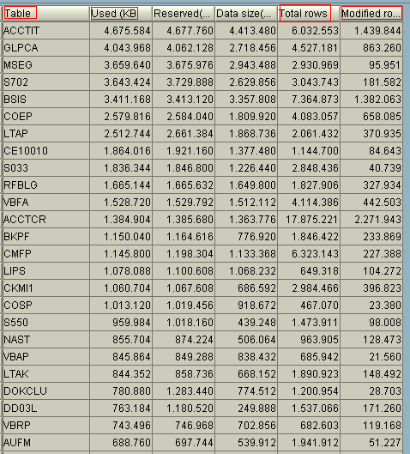

7.SAP Buffer Quality %

PXA | FTAB | TABL | TTAB

ST02-→ Detail menu analysis→ history (buffer statistics)→ of this server

