EWA CONFIGURATION :
PRE CHECKS:
- CONFIGURE SLD
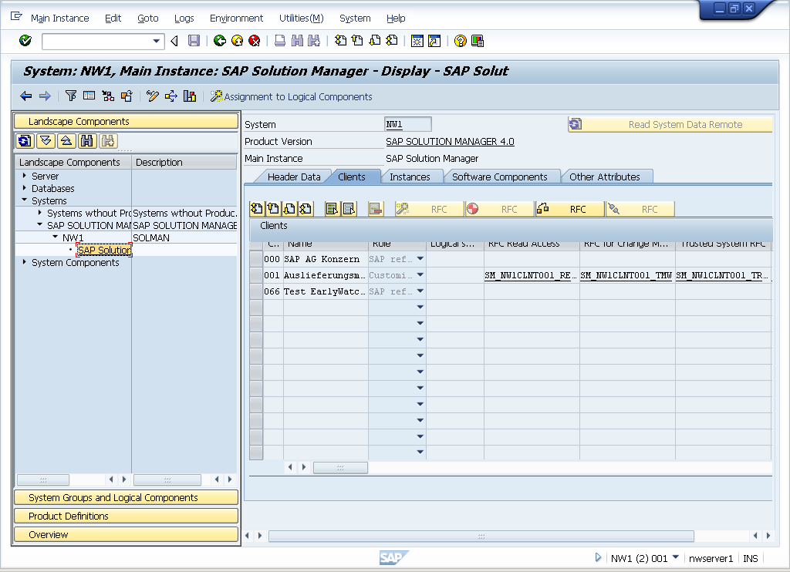
2CREATE A SOLUTION AND ADD SATELITE SYSTEM INTO SOLUTION

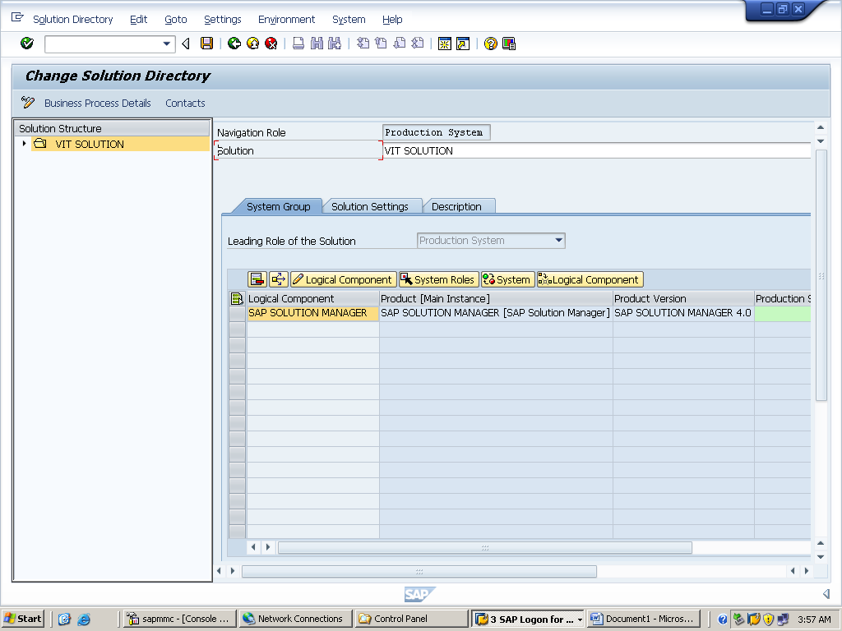

GO TO SOLUTION SETTINGS
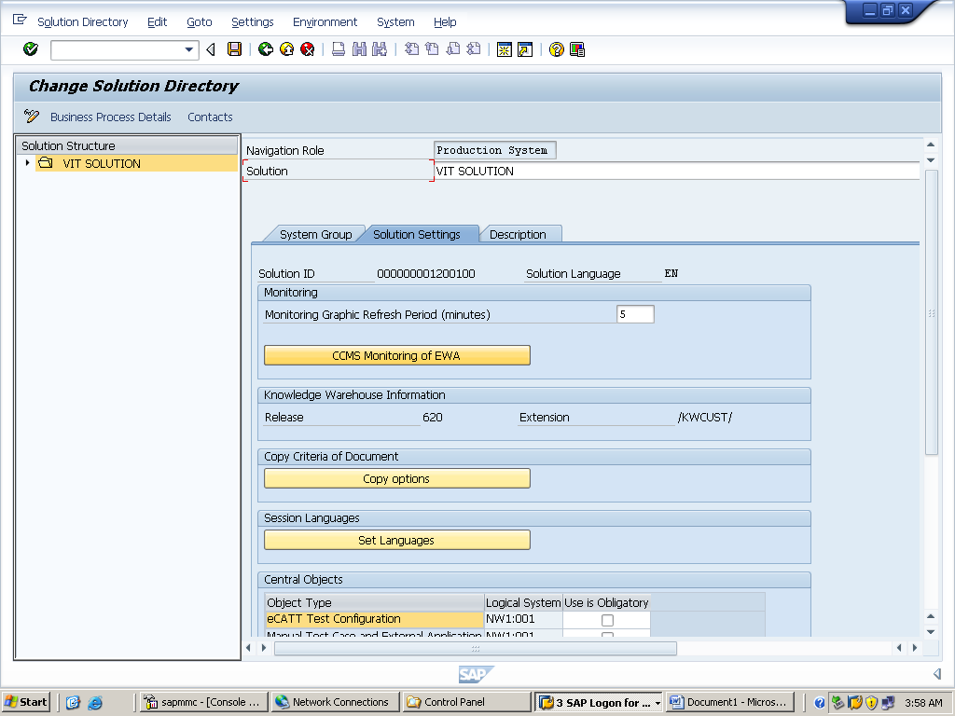

CLICK ON CCMS MONITORING OF EWA
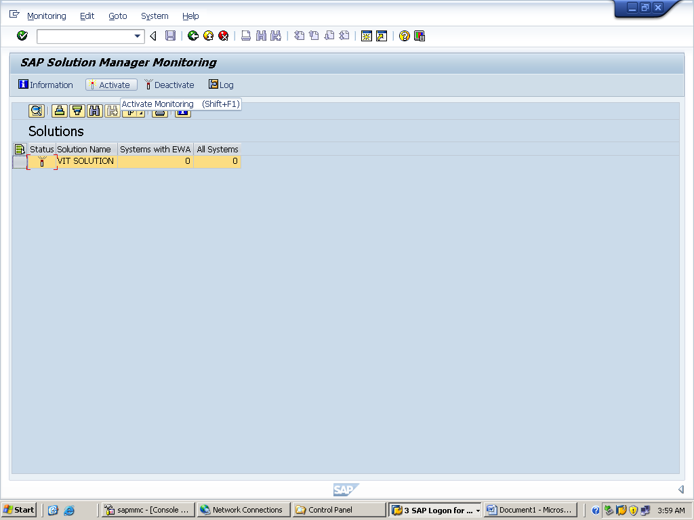
SELECT SYSTEM AND ACTIVATE
GOTO SA38 AND EXECUTE ‘RTCCTOOL’ REPORT
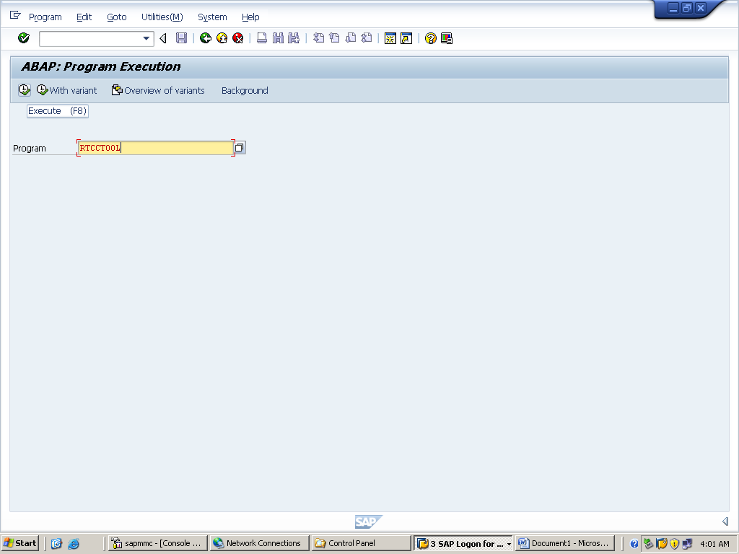

AND SELECT NEAREST SAPSERVER
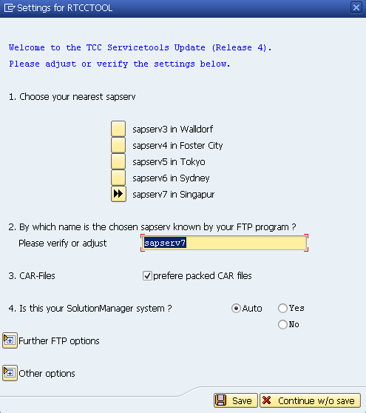
SAVE
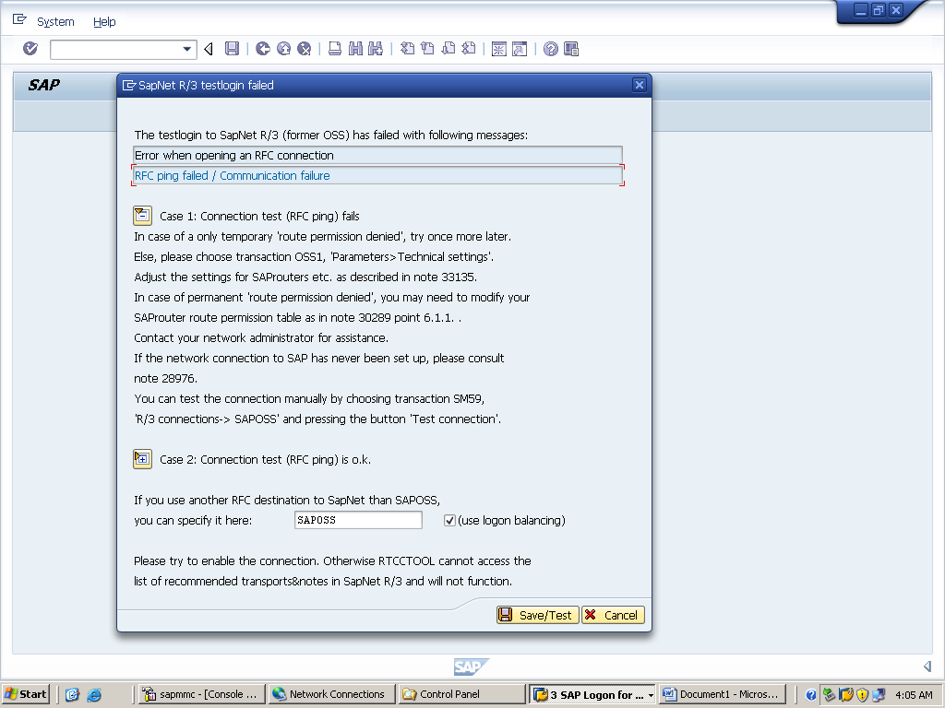

IT HAS TO RESULT IN PINGING WITH SAP SERVER

TXN SDCC

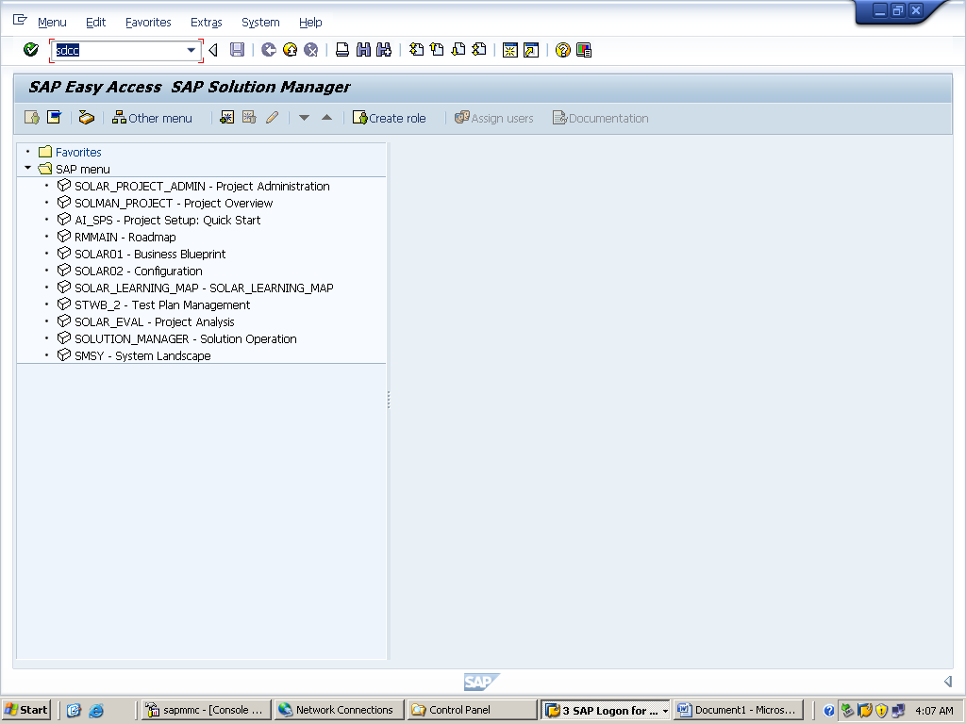

IT PROMPTS TO SCHEDULE ASM(AUTO_SESSION_MANAGER) BACKGROUND JOB CLIICK ON YES

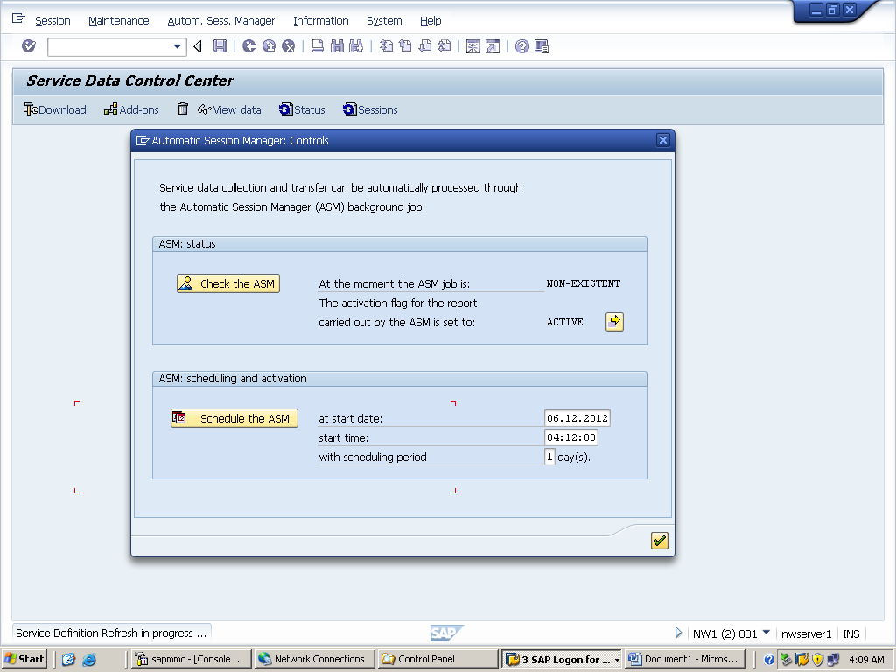
CLICK ON SCHEDULE THE ASM

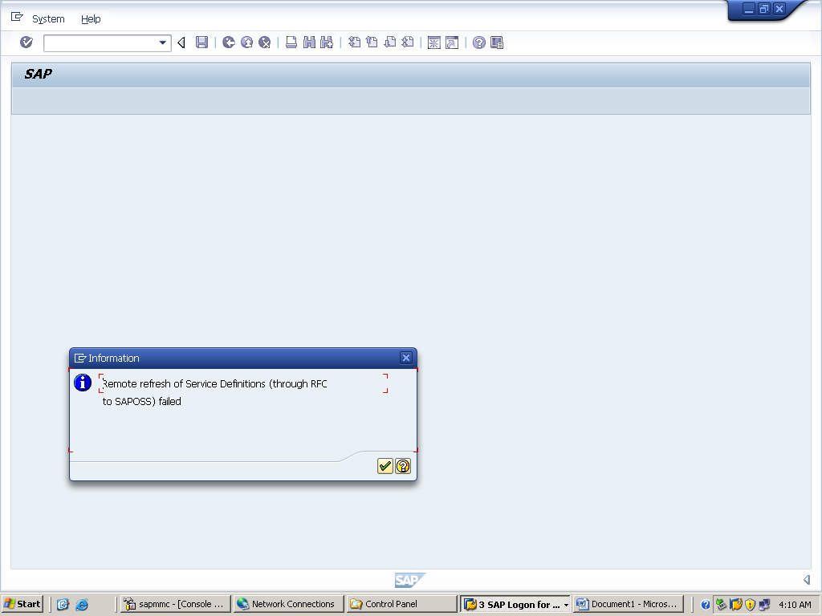

IT HAS TO PING SAPOSS SUCCESSFULLY

GO TO TXN SMSY AND SELECT SYSTEM AND GO FOR SOLUTION MANAGER ADMINISTRATION SDCCN

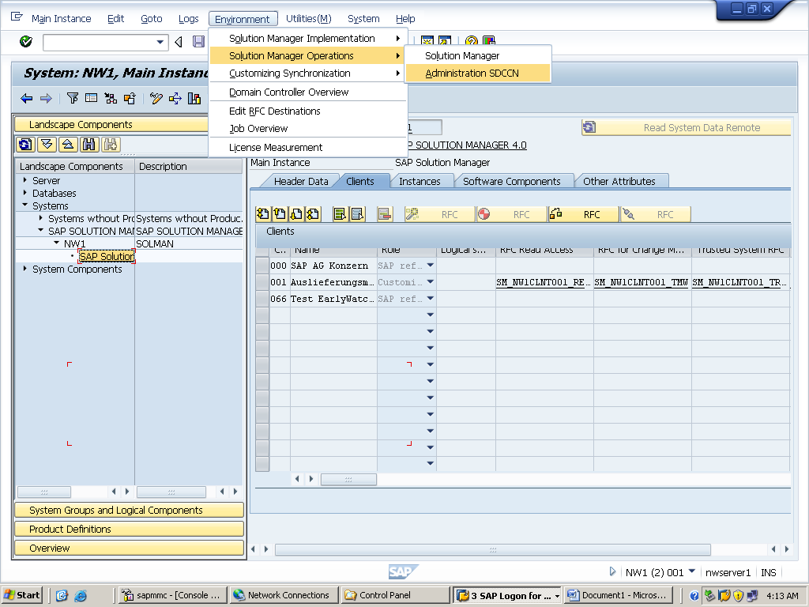

ADD SYSTEM
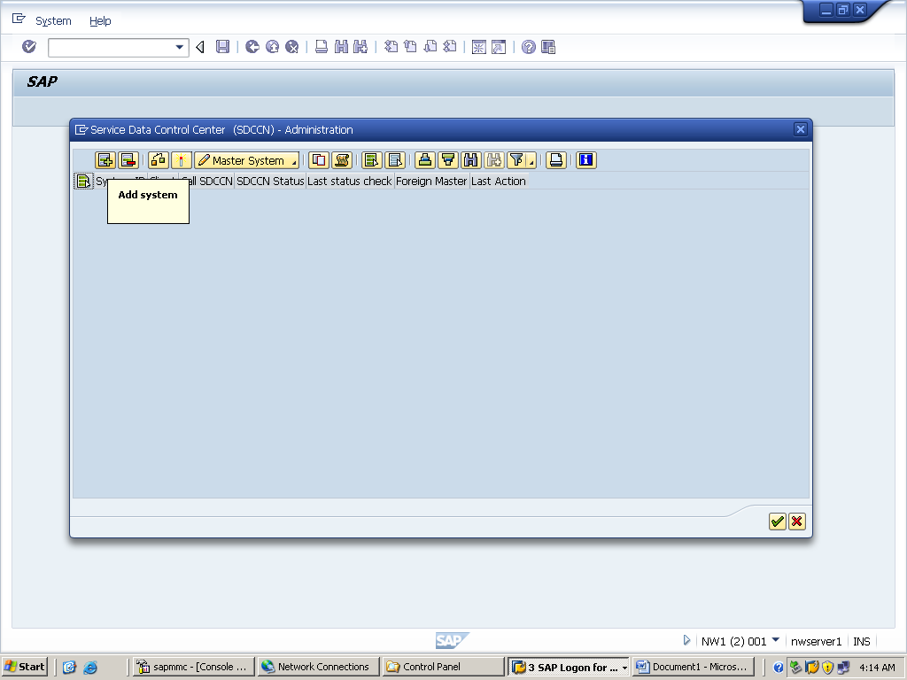

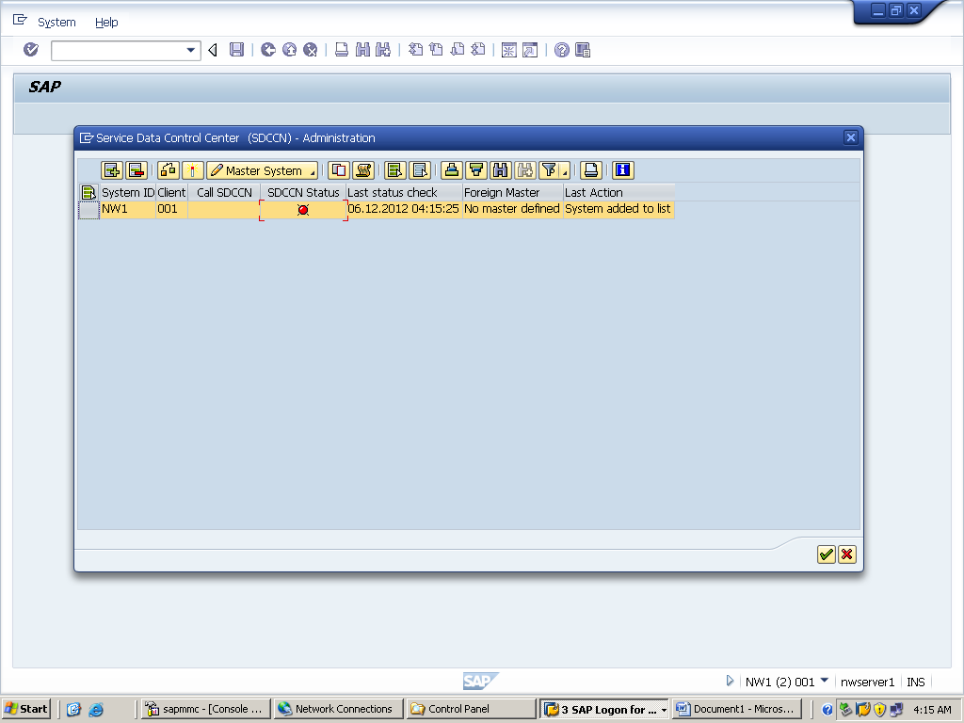

ACTIVATE

GO TO DSWP
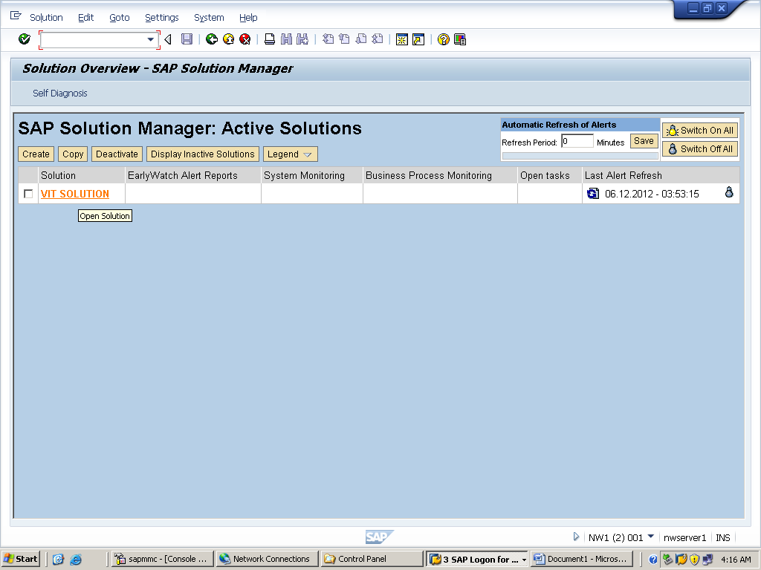

SWITCH ON ALL AUTOMATIC ALERTS
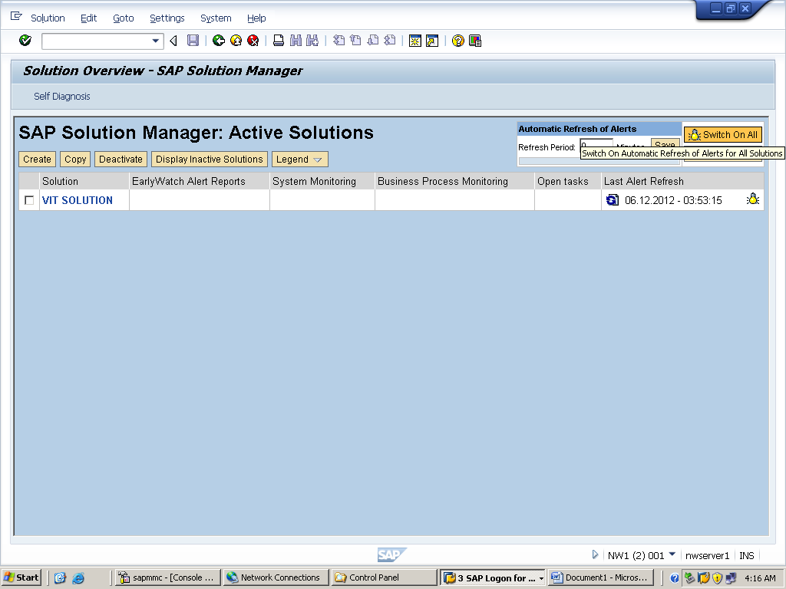

OPEN SOLUTION AND GO FOR OPERATIONS

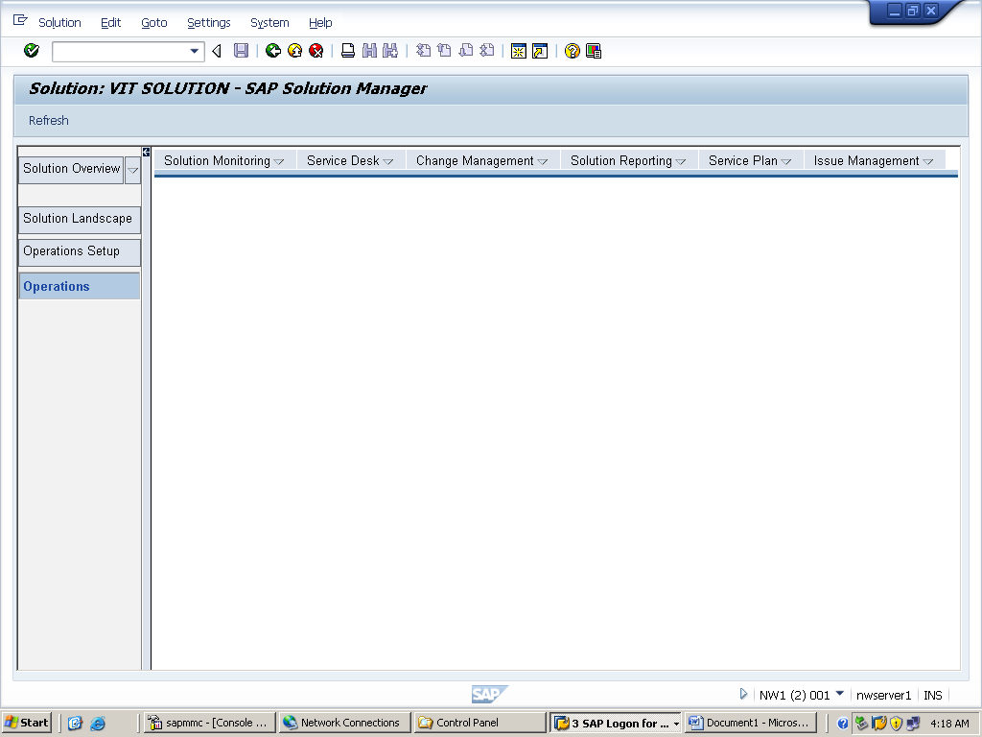
SOLUTION MONITORING EWA CREATE
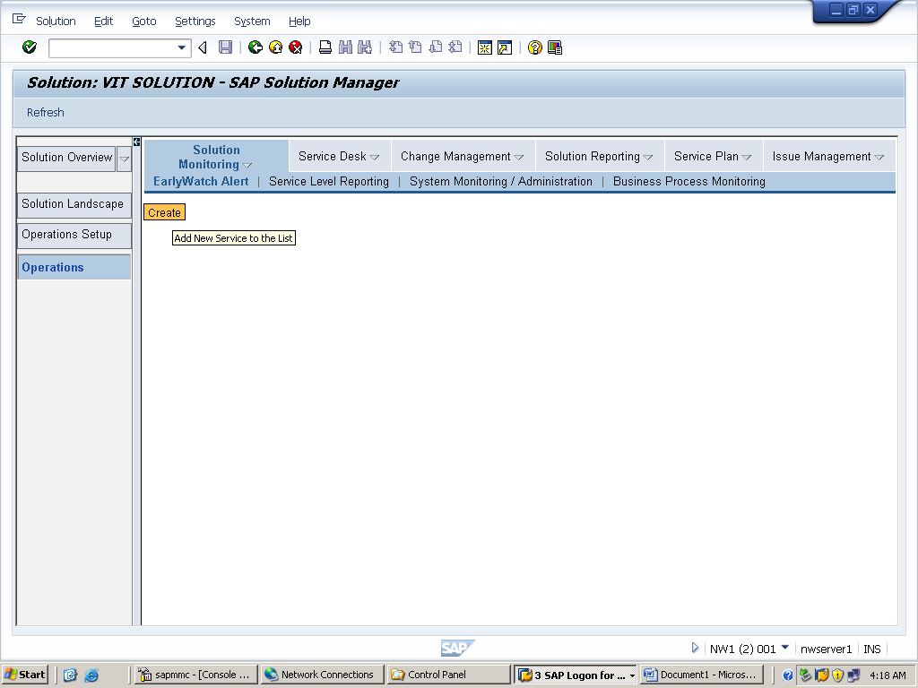

AND SELCT SYSTEM AND CONFIRM THE DATE
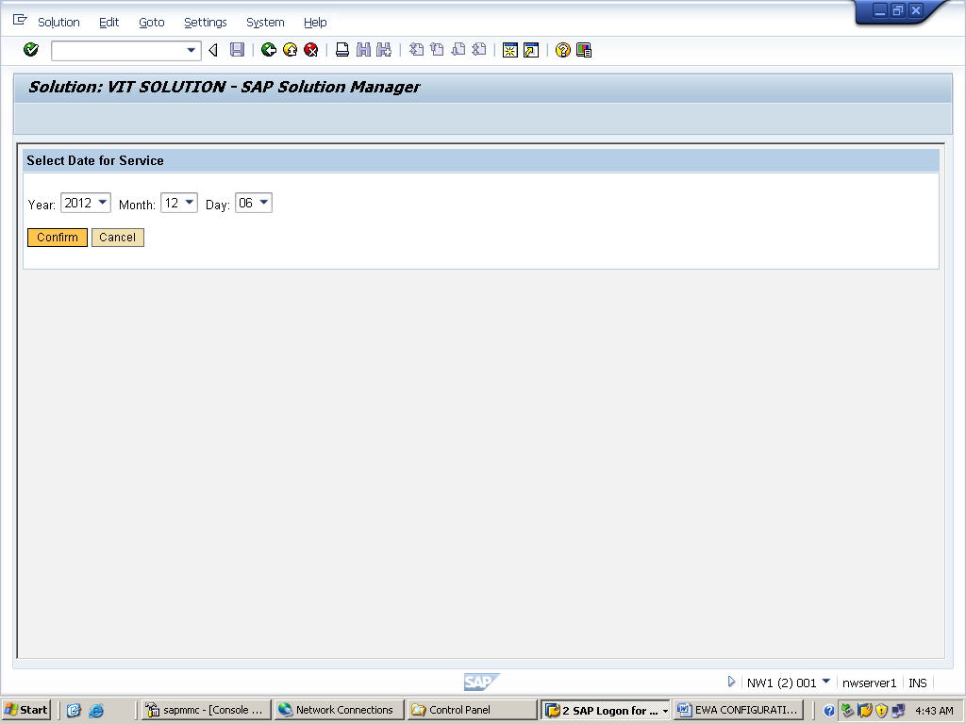

SELECT SAP EARLY WATCH ALERT FOR SOLUTIONS
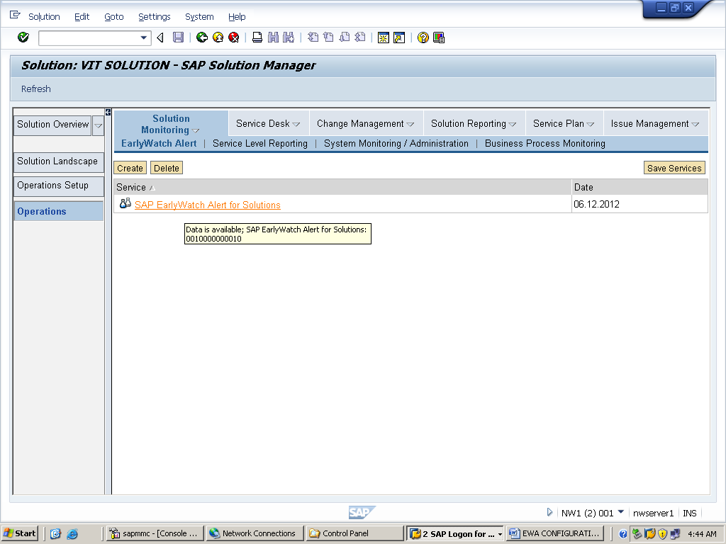
CLICK ON START SERVICE PROCESSING
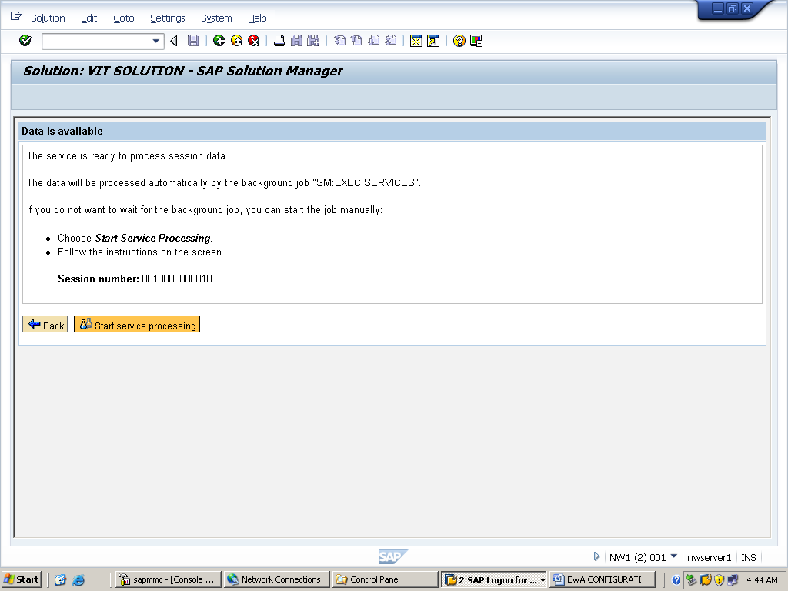
SELECT OK TO RUN BACKGROUND JOB
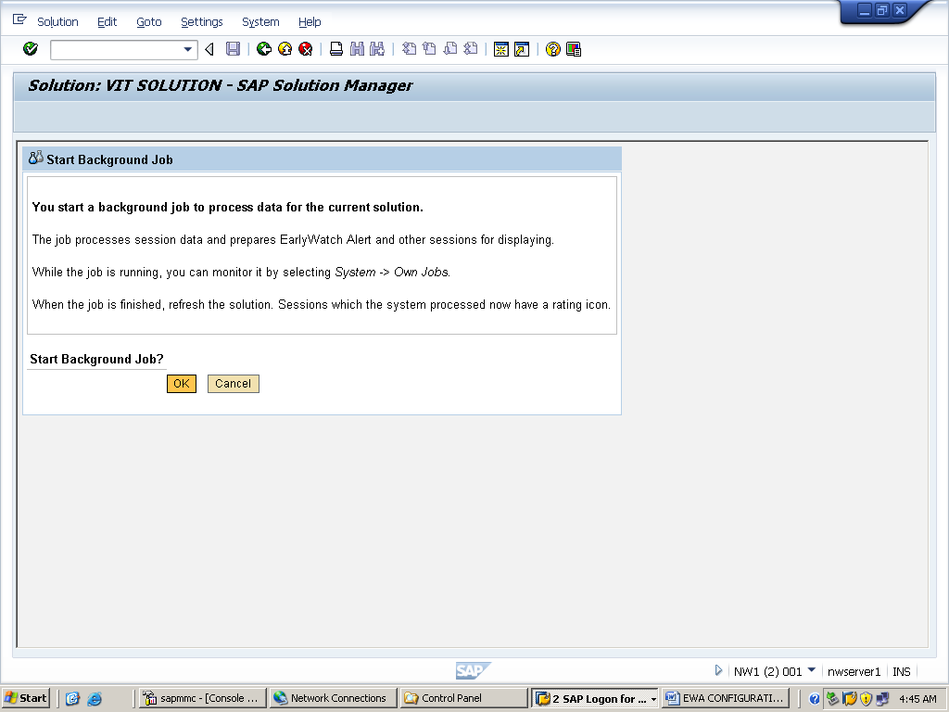

THIS IS THE ALERT WHICH CONSISTS OF ALERTS ABOUT YOUR SATELITE SYSTEM
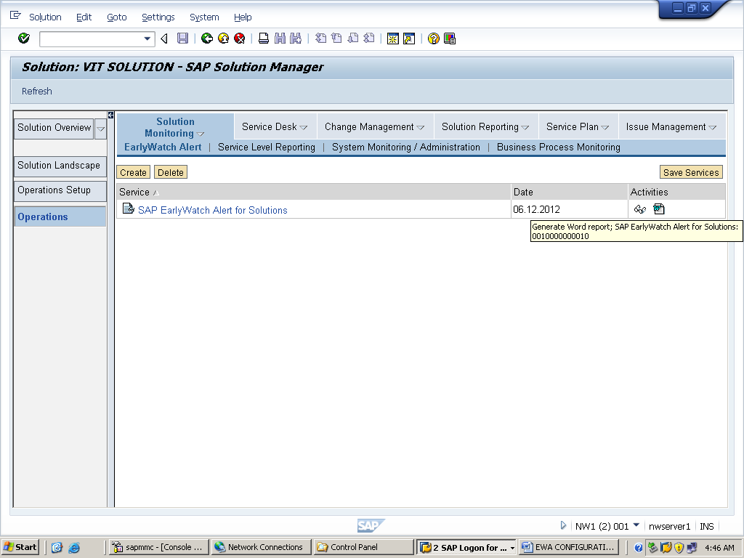
OPEN THE DOC AND SEE FOR ALERTS

