For configuring SMC follow the billow steps:-
1) Creat an RFC Destinat ion(ABAP Connection) with SM59 and don't fill the logon & security tab

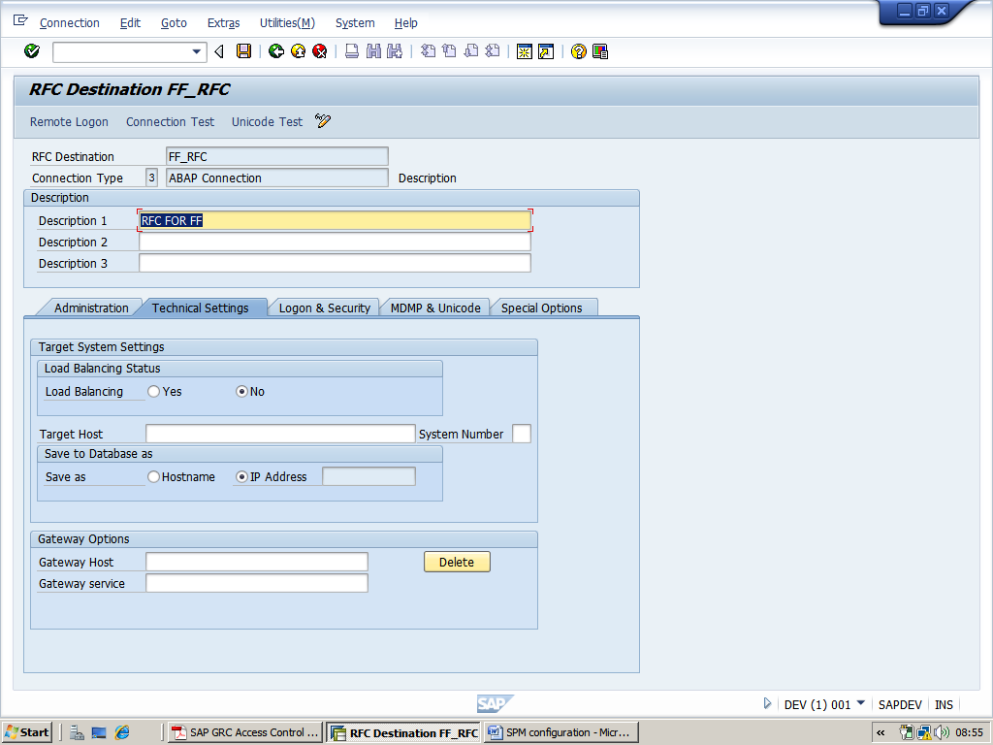

2) Go to SM36 for scheduling backgroung job with the ABAP report /VIRSA/ZVFATBAK and s
et it for hourly basis
-->copy past this report /VIRSA/ZVFATBAK
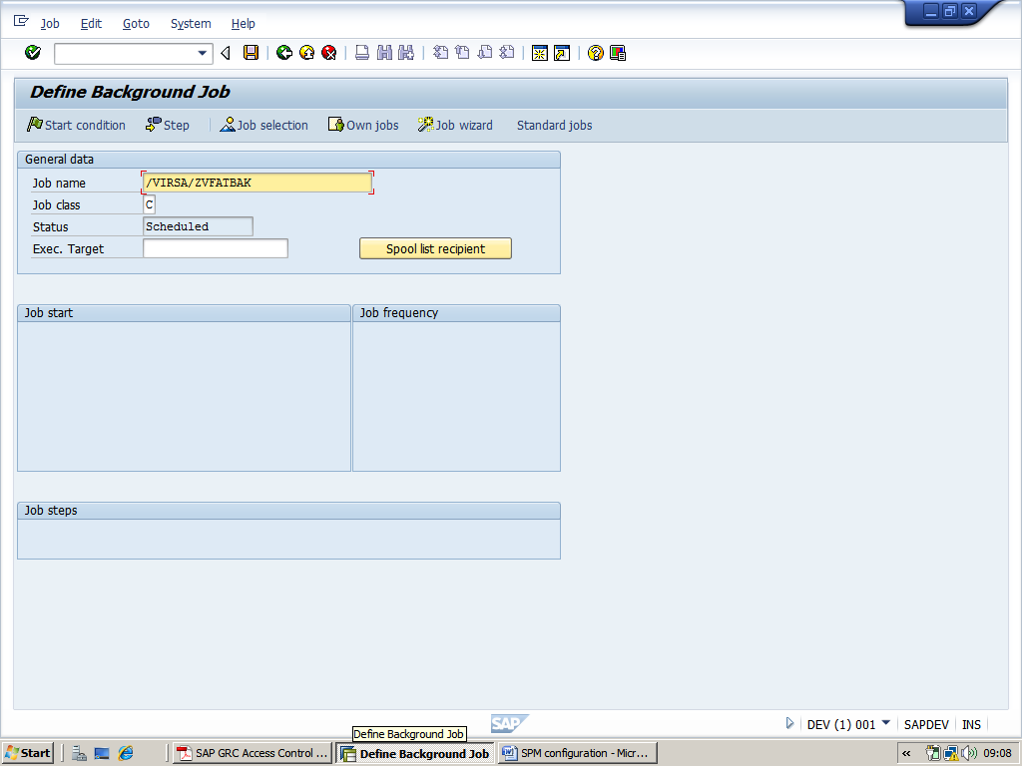
--> click on start condition botten -->click on immidieate and save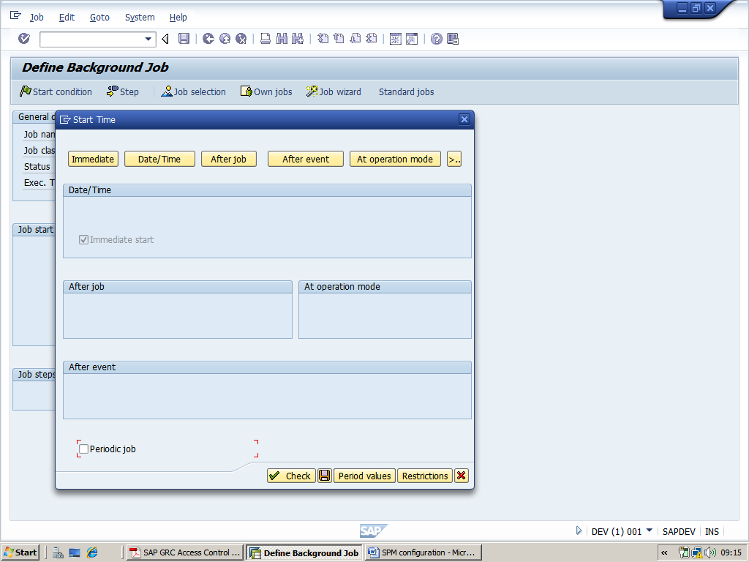

--> then click on Date/Time botten-->provide today date and time -->click on Period Values -->click hourly botton and save.
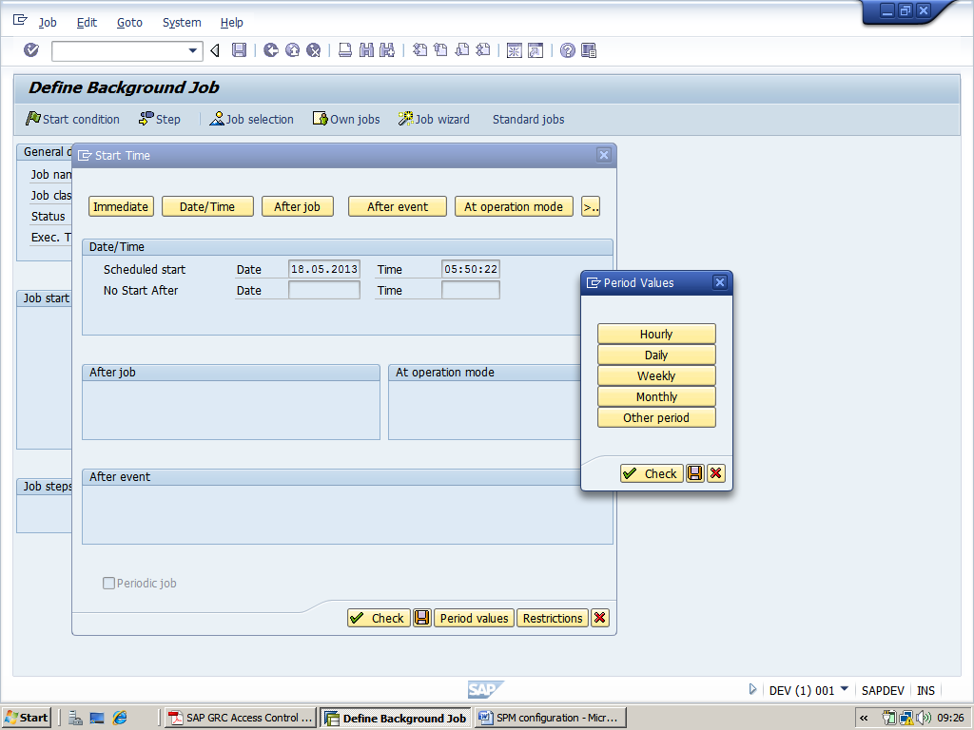
After scheduling you got this screen
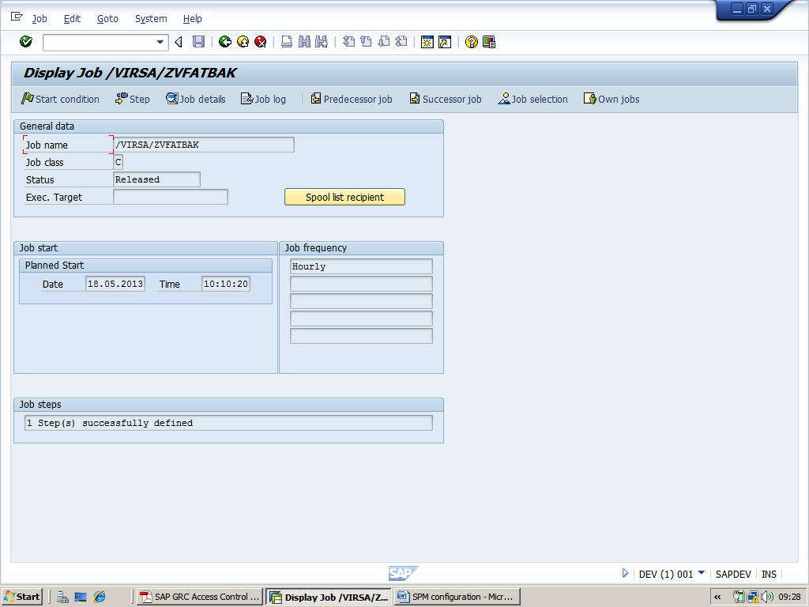
3)creat following user and asign these role to the particular user
-->Go to SU01 creat a user with name SPM ADMIN
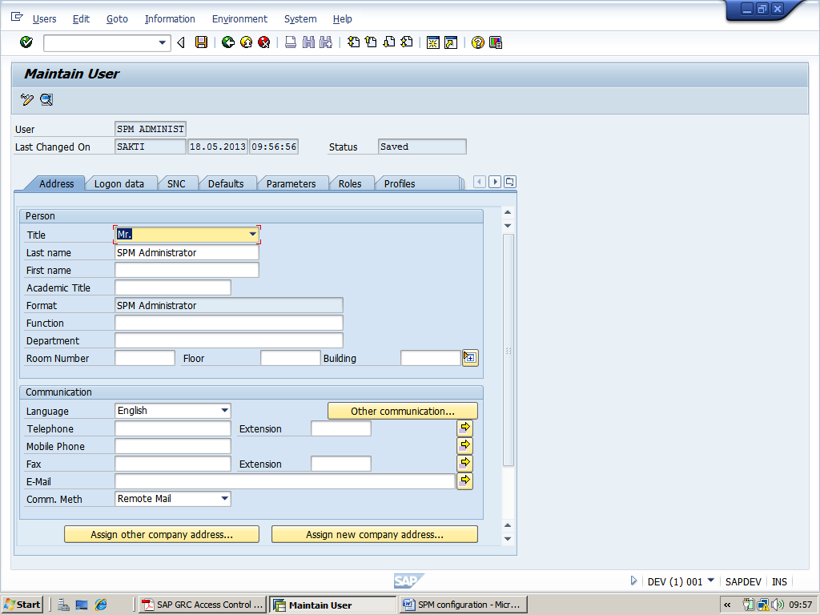
In the meanwhile creat a Z role( and asign to the particular user)-->copy the role at role text bar-->then click copy button-->change the name of role from(/VIRSA/Z_VFAT_ADMINISTRATOR) to (Z: VIRSA_Z_VFAT_ADMINISTRATOR) and click on copy selectively 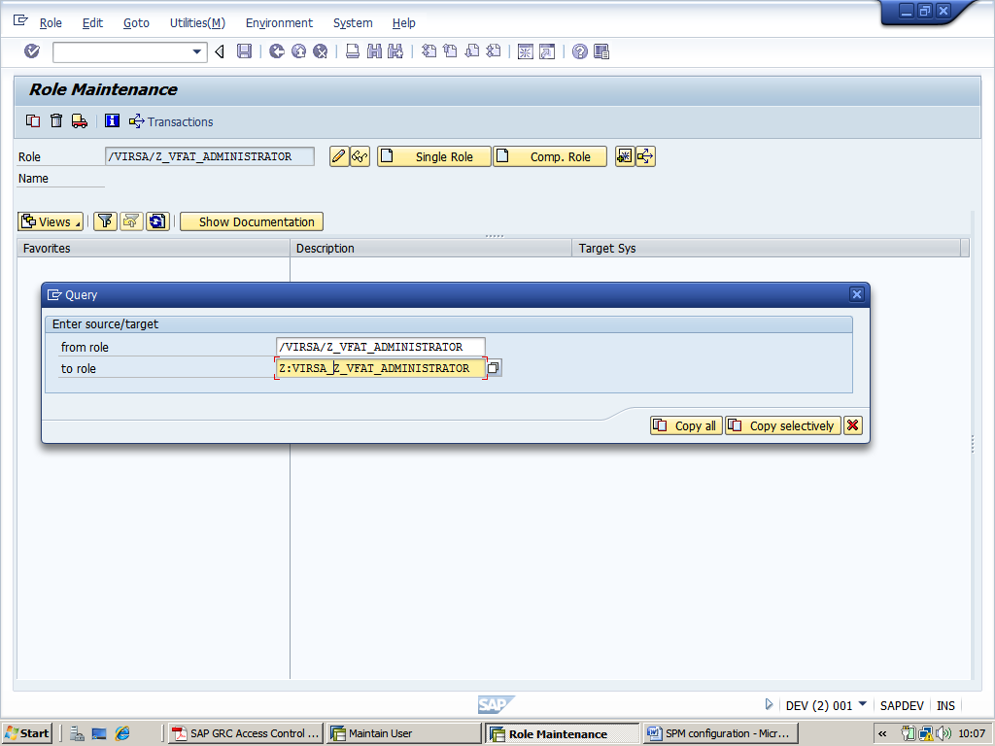
un check Personalization and continue
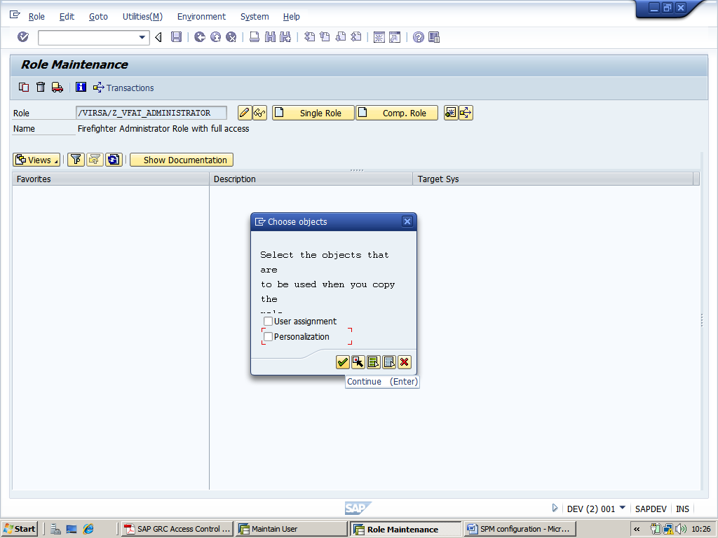
-->Go to change
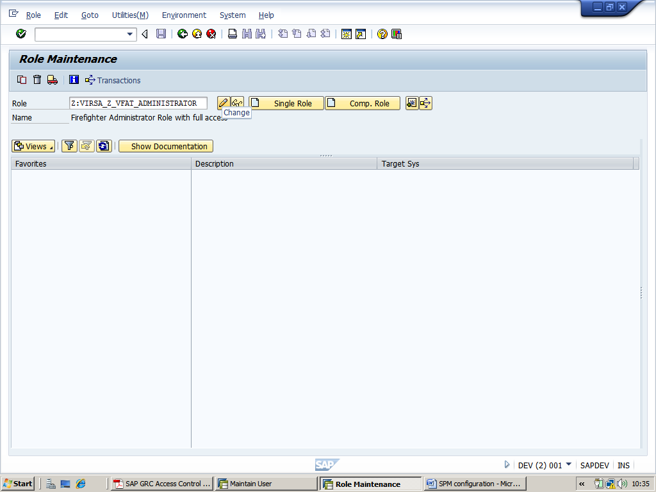

-->click on authorization tab and click creat profile and click change authorization data
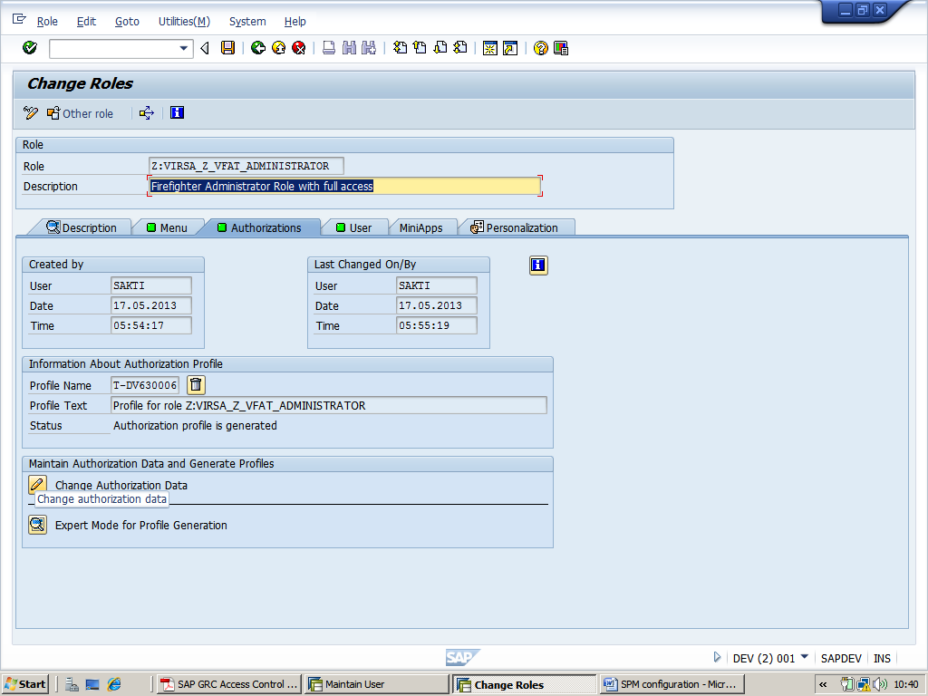
--click generate and go back for privious screen
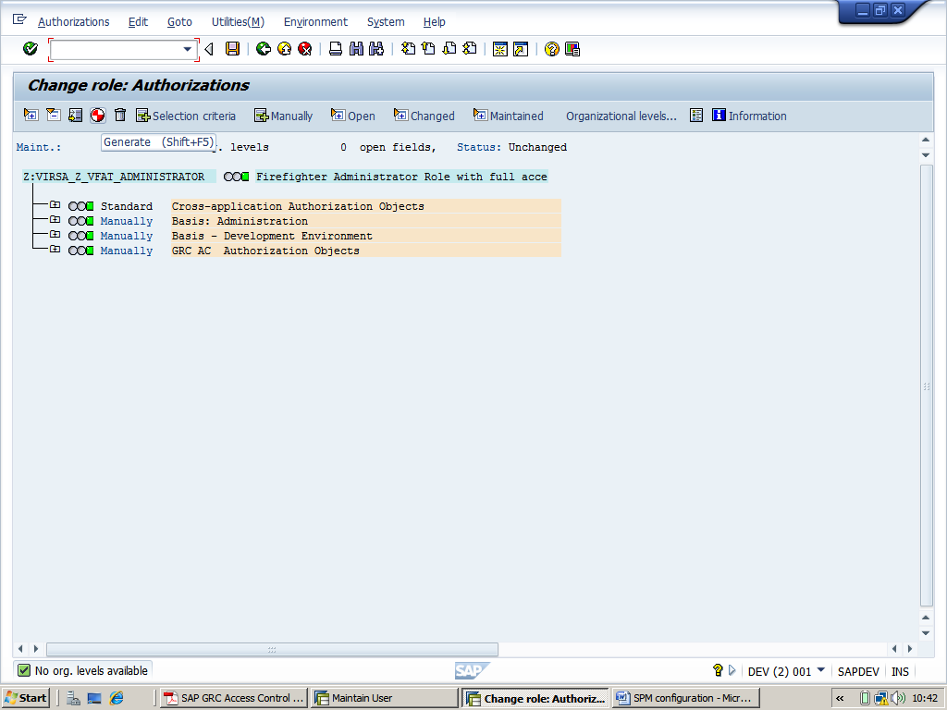

-->Go to user tab and asign the <user name> (SPM ADMINIST) -->click on user comparision-->save
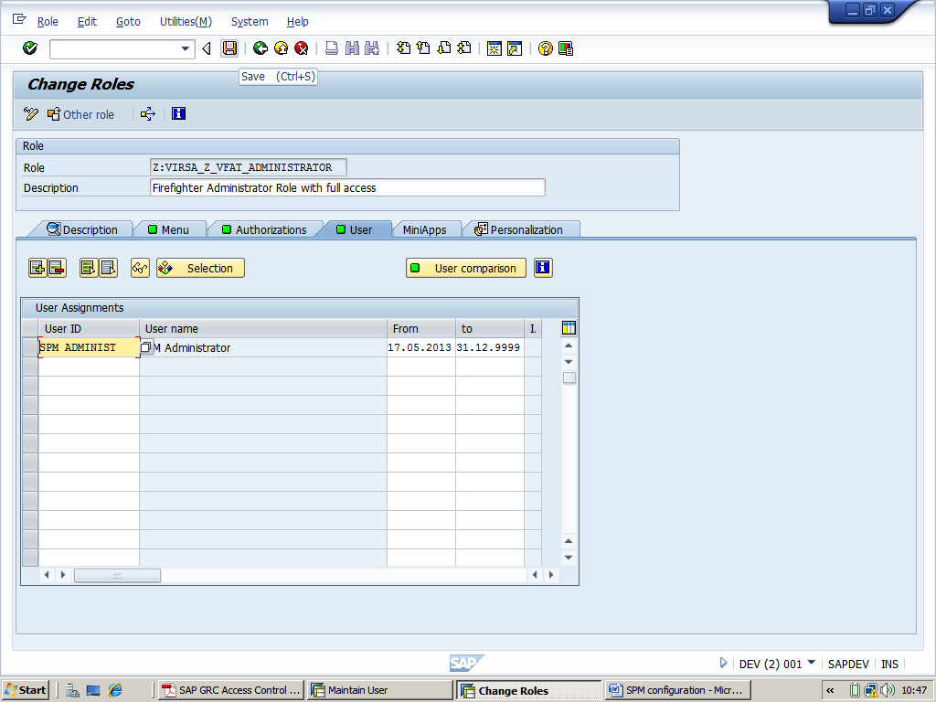
ii) Creat second user
-->Go to SU01 creat a user with name OWNER
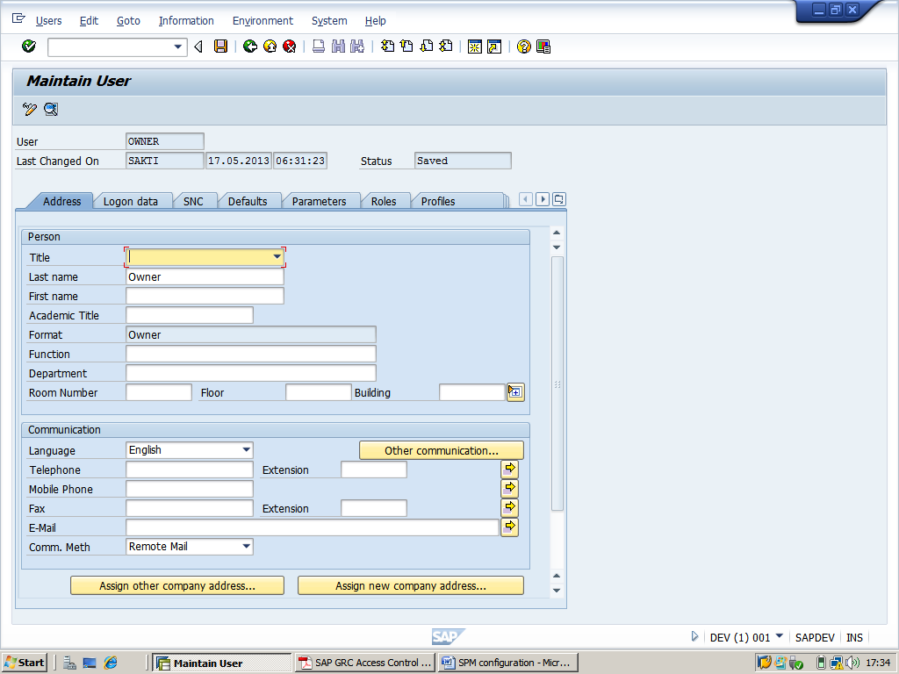

In the meanwhile creat a Z role( and asign to the perticular user)-->Hit PFCG-->copy the role at role text bar-->then click copy button-->change the name of role from(/VIRSA/Z_VFAT_ID_OWNER) to (Z:VIRSA_Z_VFAT_ID_OWNER) and click on copy selectively un check Personalization and continue (as like the privious user id )
-->click on authorization tab and click creat profile and click change authorization data
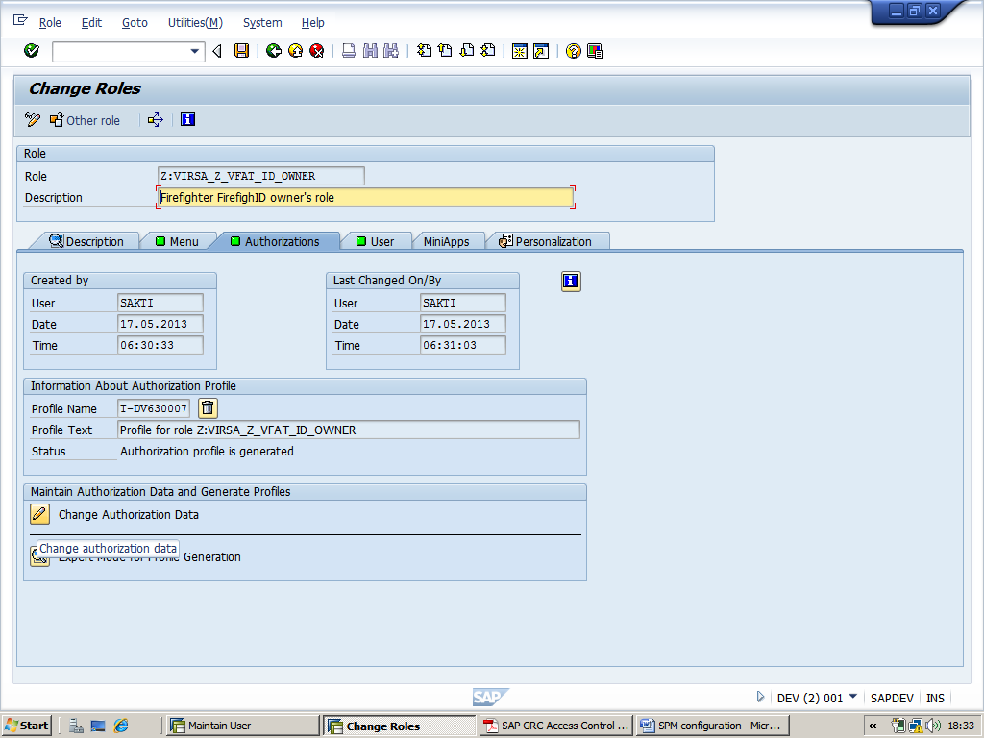
--click generate and go back for privious screen
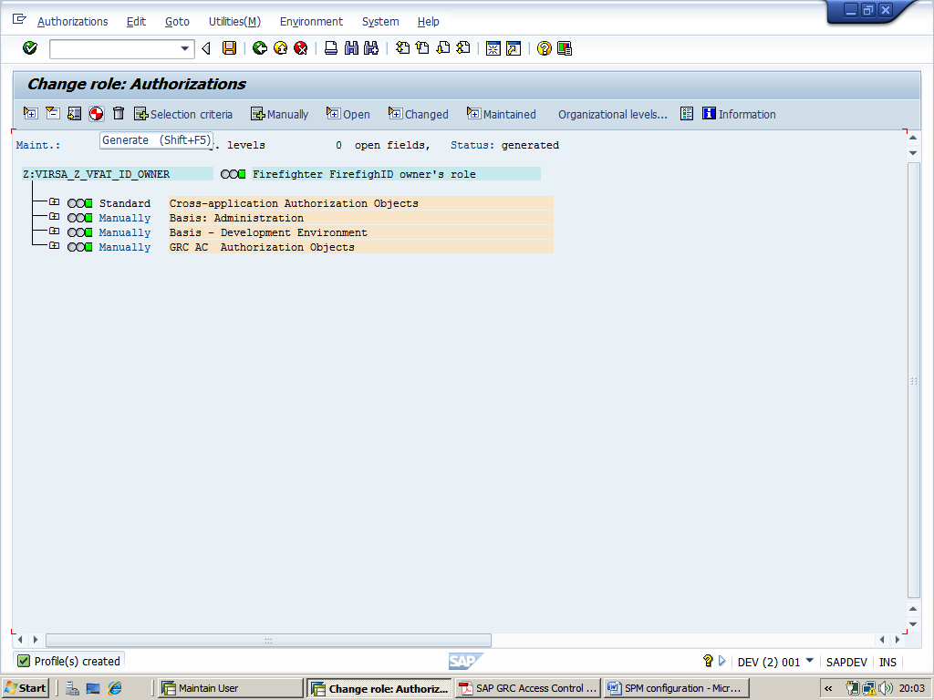
-->Go to user tab and asign the <user name> (OWNER) -->click on user comparision-->save
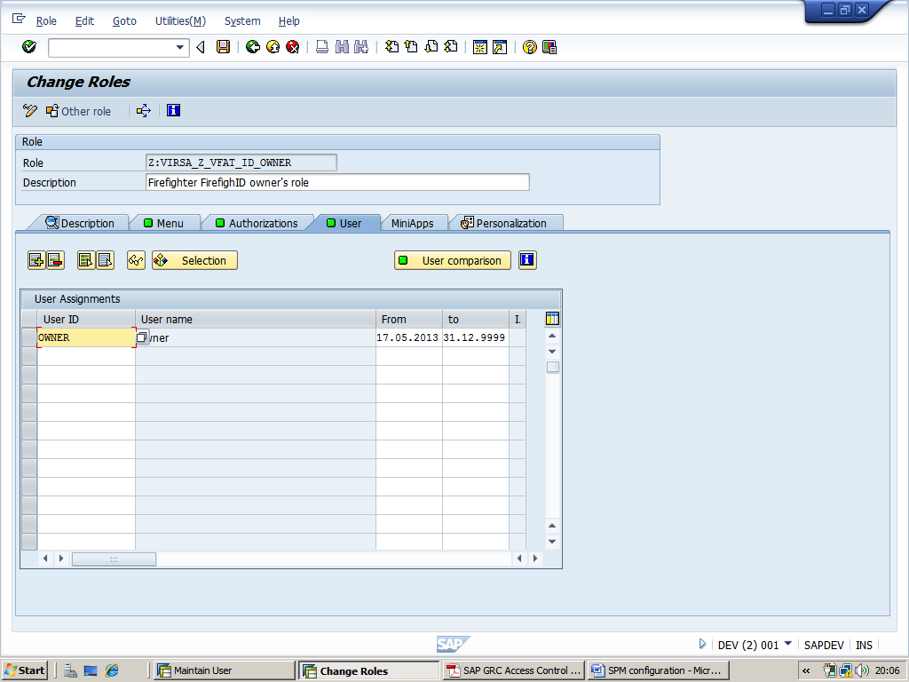
iii) Creat third user id(Controler) and asign the role (/VIRSA/Z_VFAT_ID_OWNER (but with objects GRCFF_0001 & S_TABU_DIS restricted display only!)

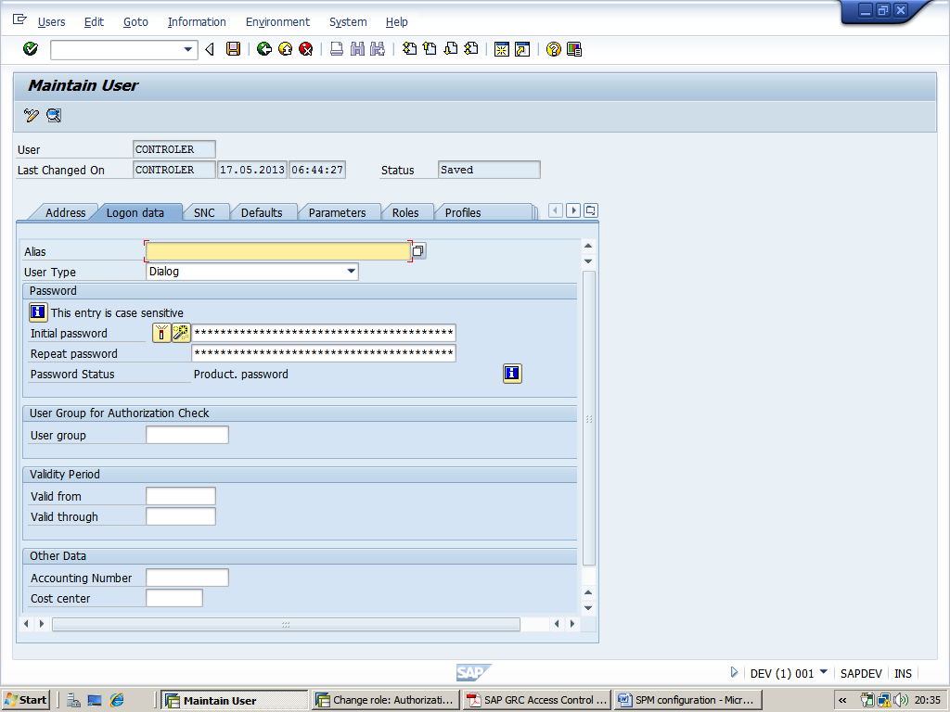

In the meanwhile creat a Z role( and asign to the particular user)-->Hit PFCG-->copy the role at role text bar-->then click copy button-->change the name of role from(/VIRSA/Z_VFAT_ID_OWNER) to (Z:VIRSA_Z_VFAT_ID_OWNER_DISPL) and click on copy selectively un check Personalization and continue (as like the privious user id )

-->click on authorization tab and click creat profile and click change authorization data
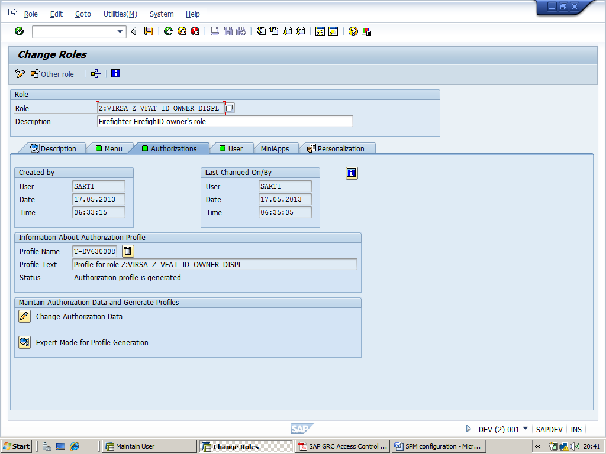

--> find the object GRCFF_0001 & S_TABU_DIS and provide restricted display only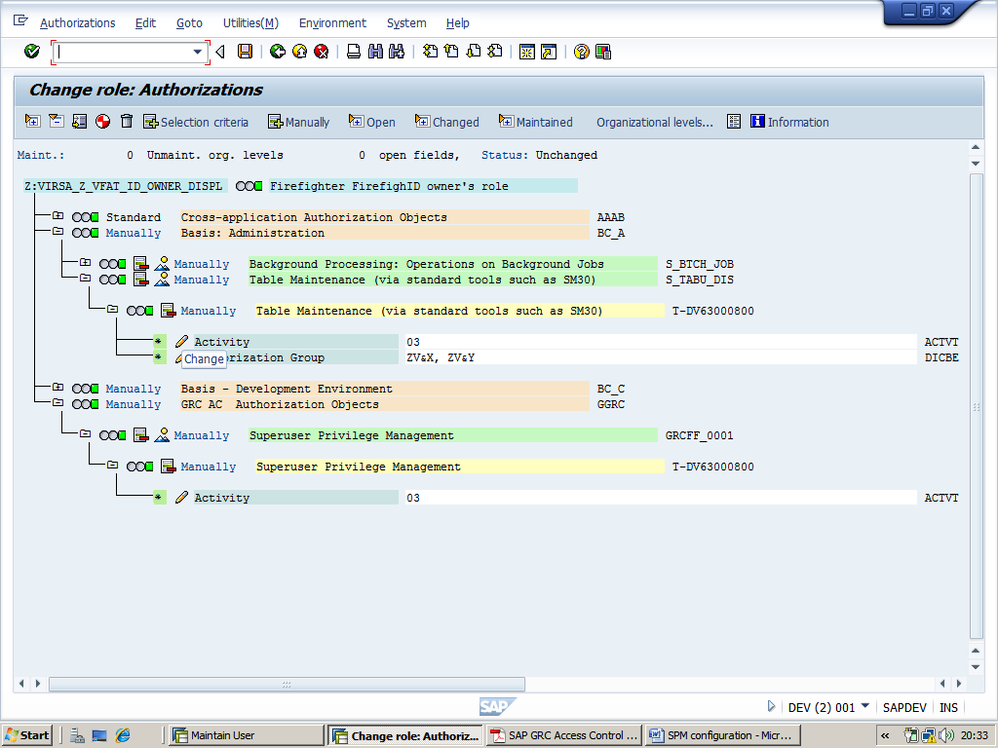

-->Go to user tab and asign the <user name> (Controler) -->click on user comparision-->save
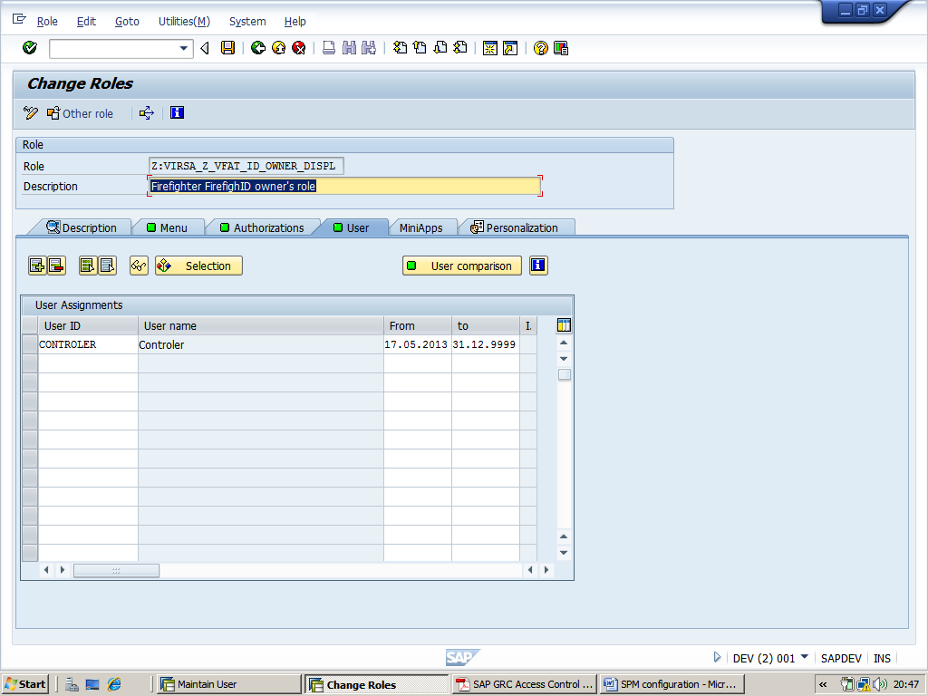
iv) Creat fourth user id< Firefighter ID >(FFID) and asign the Superuser roles (SAP_ALL)

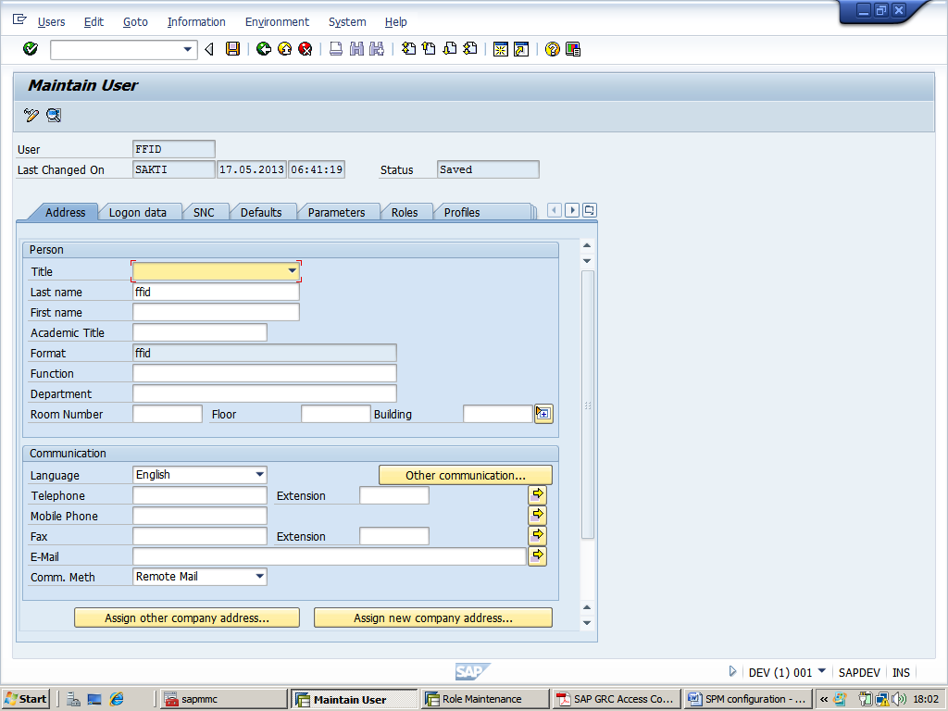
In the meanwhile creat a Z role( and asign to the perticular user)-->Hit PFCG-->type (Z:VIRSA_Z_SAP_ALL)-->click on single role
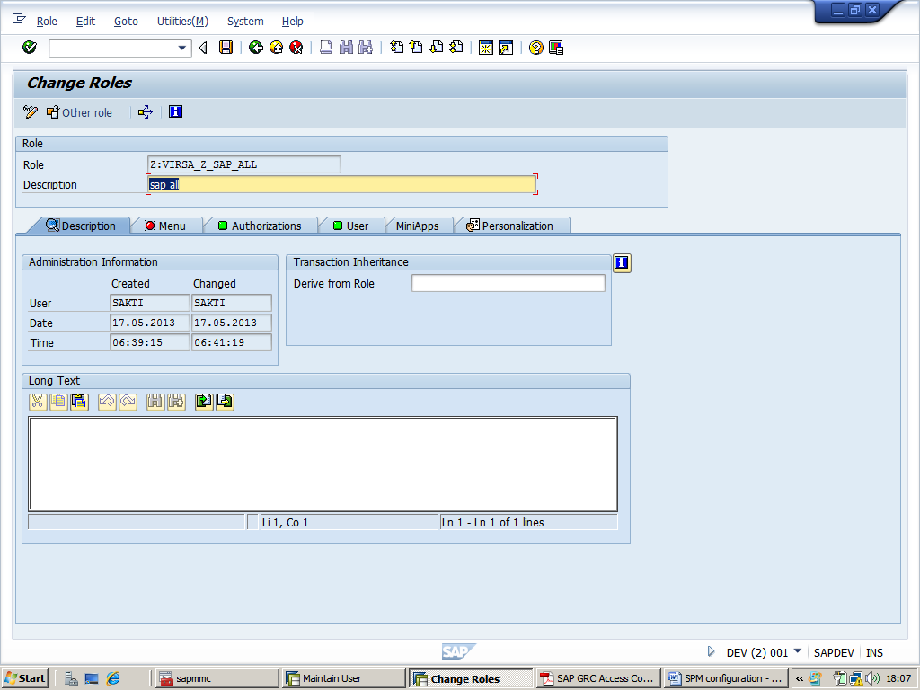
-->click save

-->then click on Authorization tab-->click creat profile-->click on change Authorization Data
-->click on SAP_ALL--> and click Adopt reference
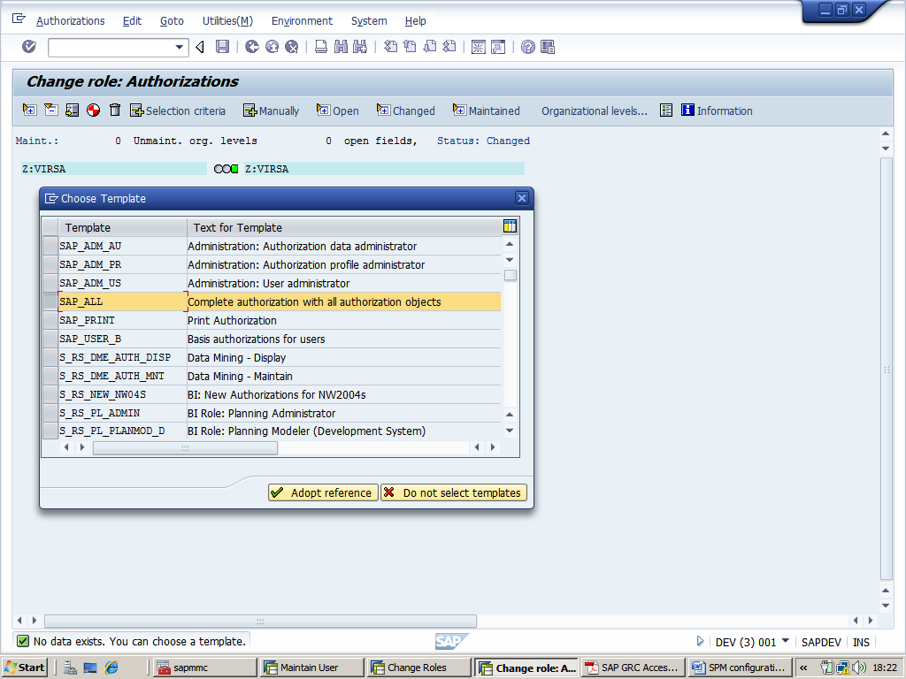
-->insert all authorization(click Yes)-->click continue
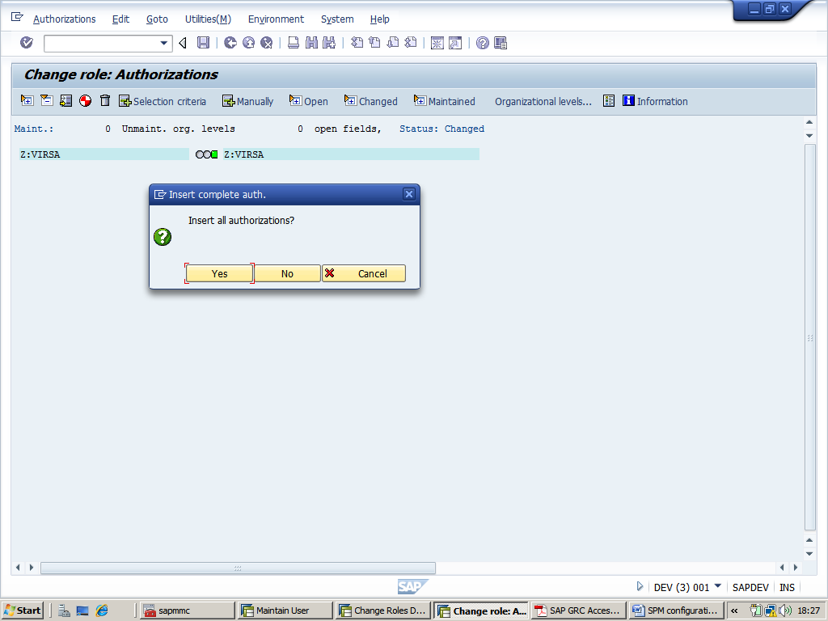

-->Then go to Organization level -->click on Full authorization -->click Save-->click on generat-->click back
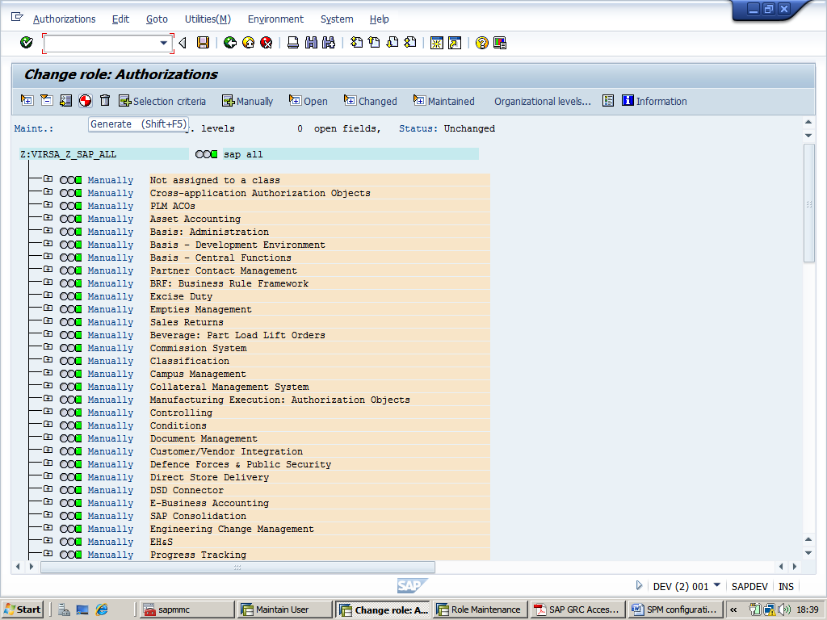
-->go to user tab -->prvide <user name>(FFID)-->click user comparision
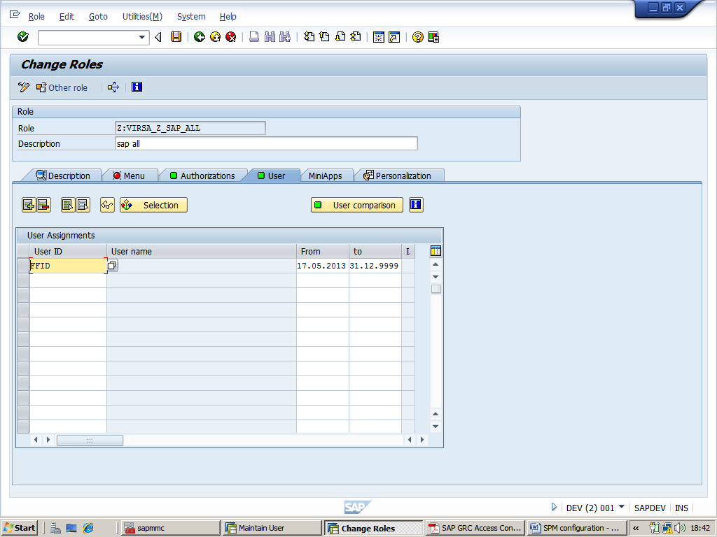

v) Creat fifth user id(Firefighter) and asign the role (/VIRSA/Z_VFAT_FIREFIGHTER)
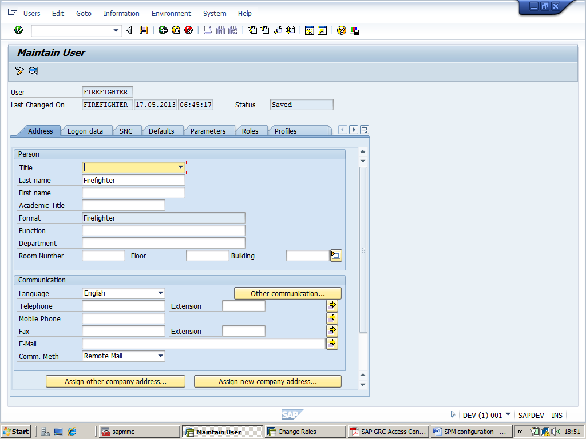
In the meanwhile creat a Z role( and asign to the perticular user)-->Hit PFCG-->copy the role at role text bar-->then click copy button-->change the name of role from(/VIRSA/Z_VFAT_FIREFIGHTER) to (Z:VIRSA_Z_VFAT_FIREFIGHTER) and click on copy selectively un check Personalization and continue (as like the privious user id )
-->click on authorization tab and click creat profile and click change authorization data
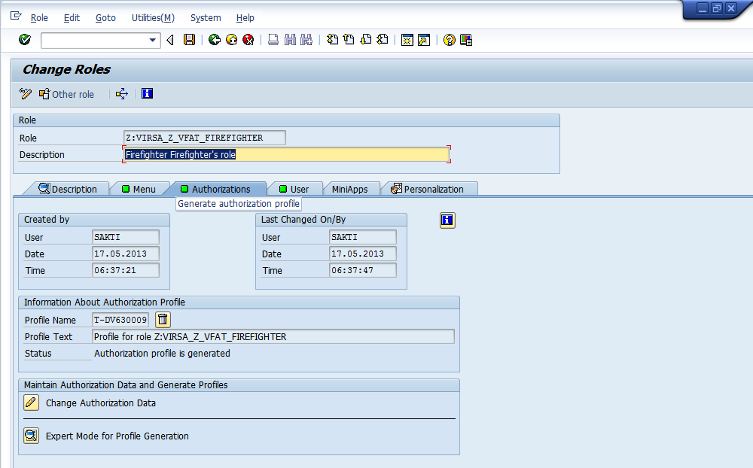

--click generate and go back for privious screen
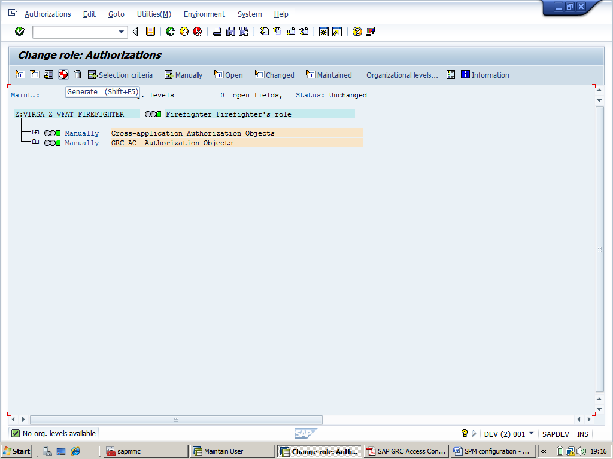

4) Logon as SPM Administrator and start transaction /N/VIRSA/VFAT

-->click Owner -->asign owner and controller to FFID(as like screen)
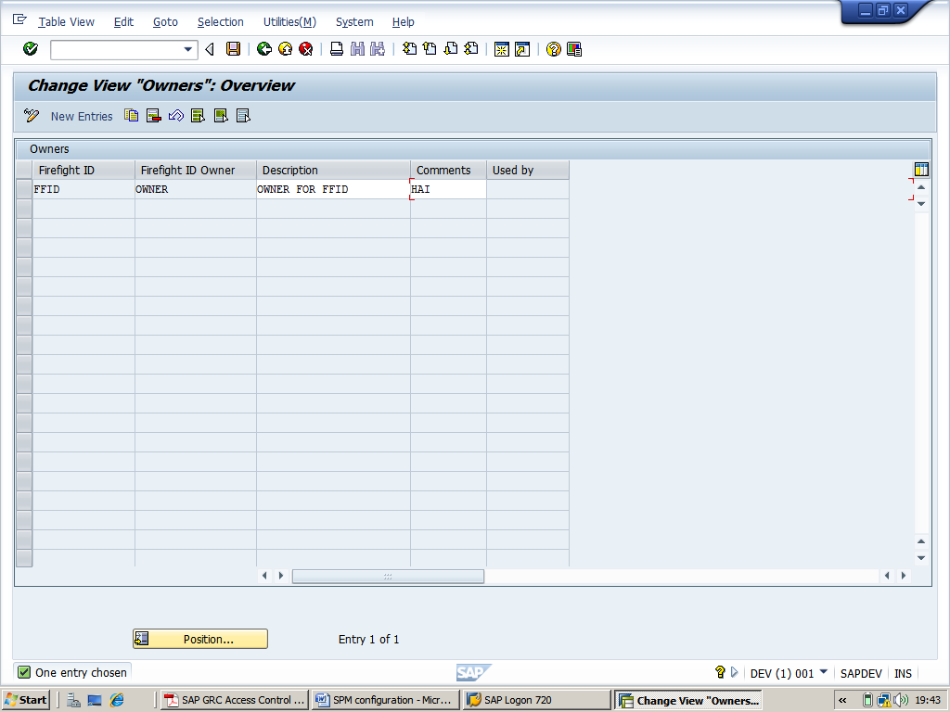
-->Maintain Security Tables, which requires the knowledge of the passwords of the FireFighterIDs
-->click on new entry and fill the table(as like screen , also in password text box fill the desire password and press enter to change password to hexadesimal charecter)-->then go back
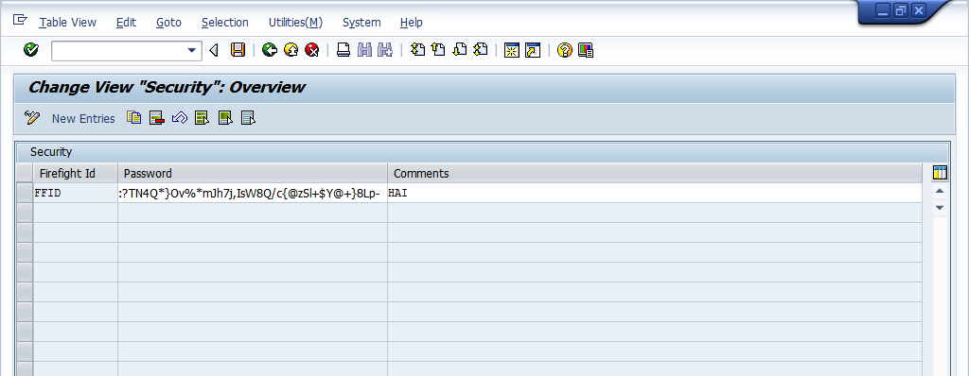

-->Access to the Tool Box containing a number of reports

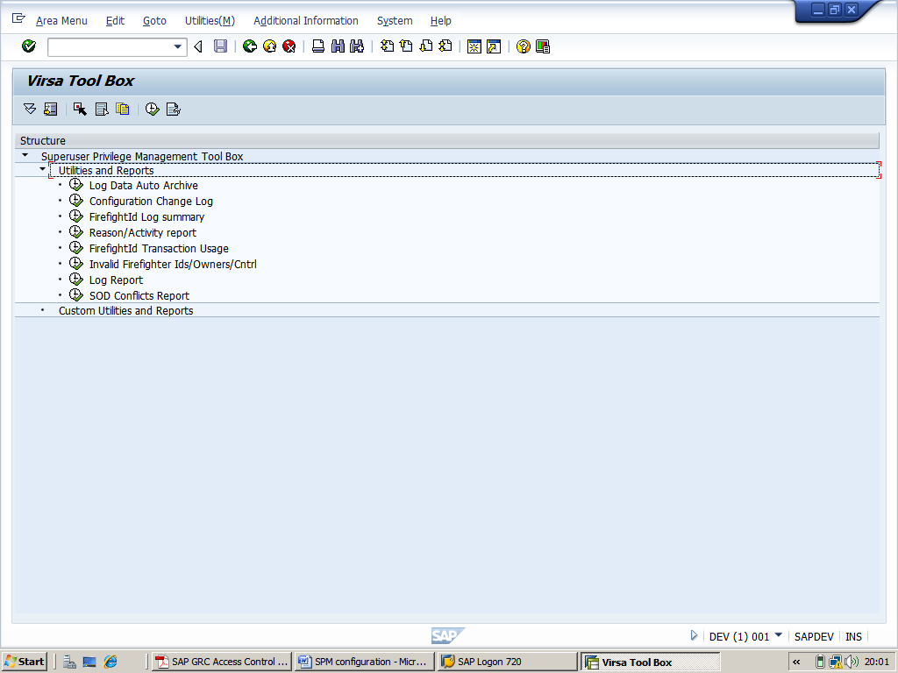
then go back-->click configuration

-->Fill the form
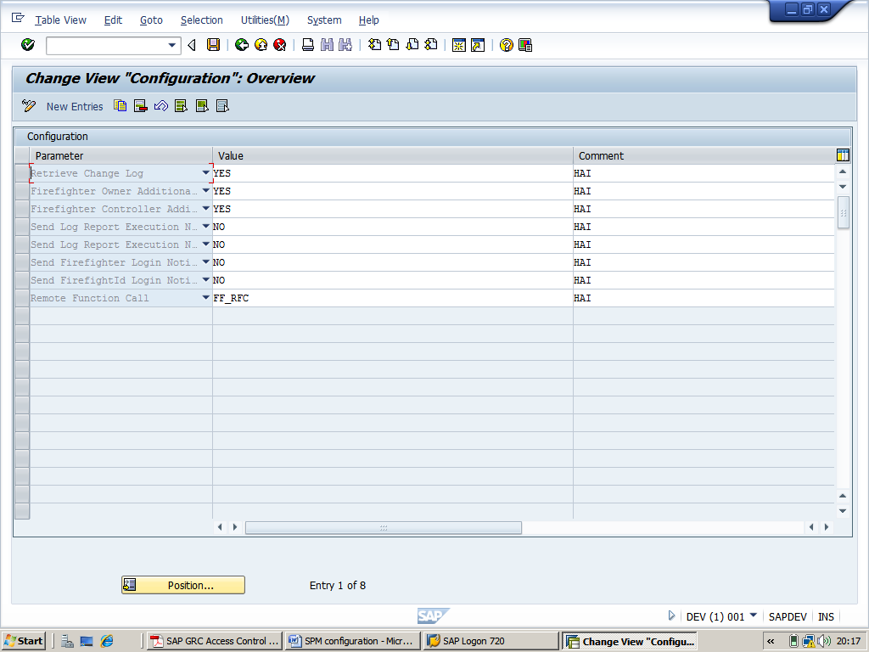
Logon as SPM Administrator and click in transaction /N/VIRSA/VFAT on the „Reason Code“ button

Then create reason codes which Firefighters will have to select from upon activation of Firefighter IDs that were granted to them.

Logon as Owner (or Administrator) and click in transaction /N/VIRSA/VFAT on the „Firefighter“ button

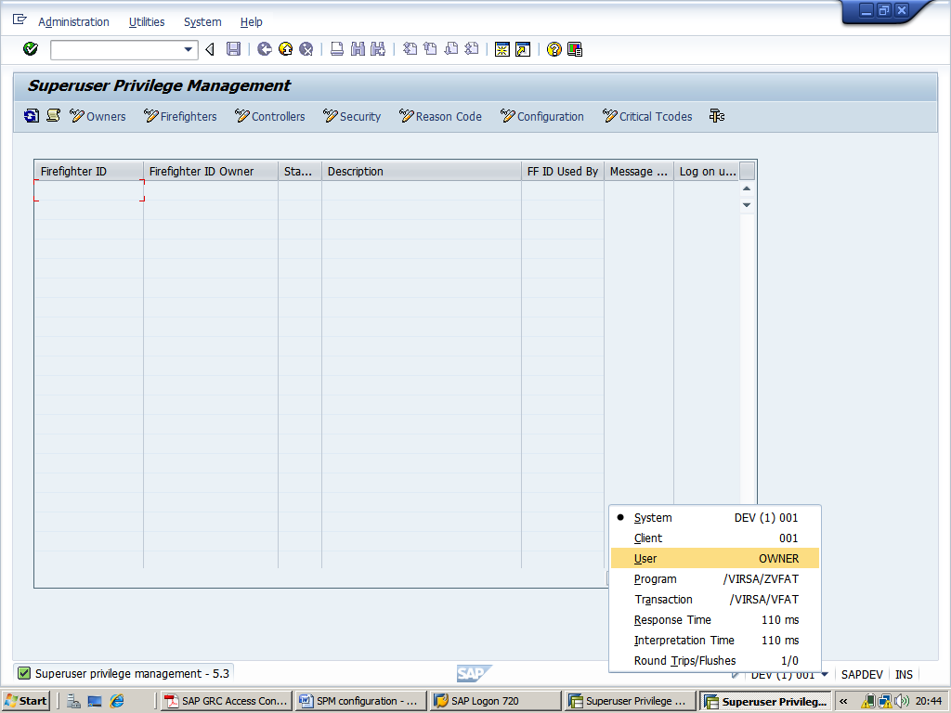

Then assign Firefighter IDs to Firefighters

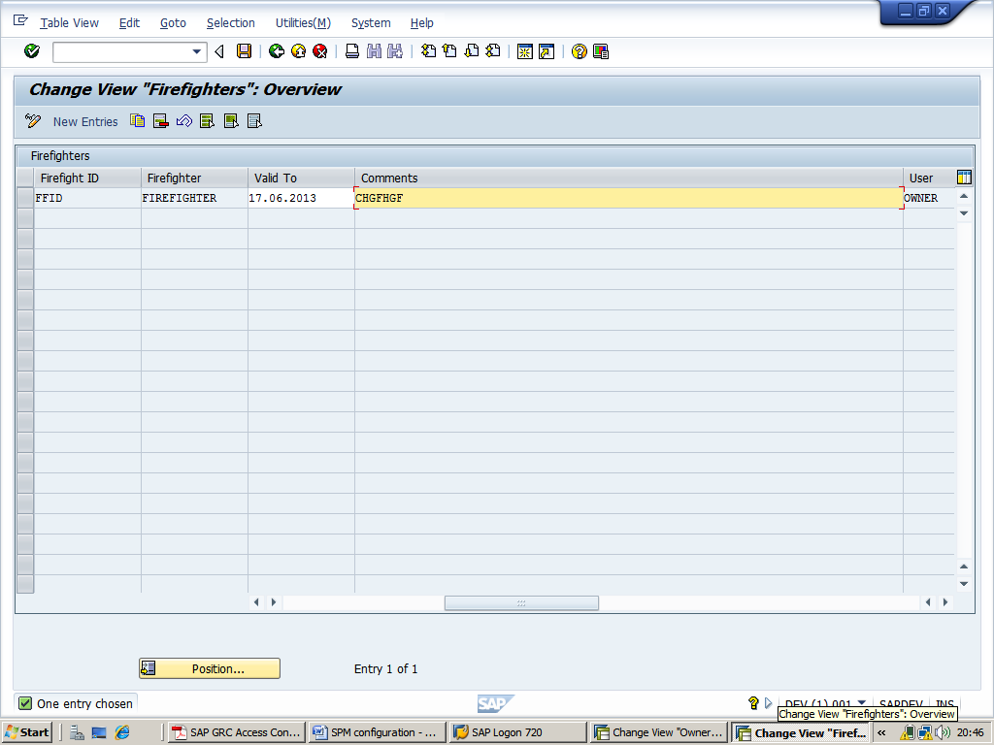

Logon as Owner (or Administrator) and click in transaction /VIRSA/VFAT on the „Controllers“ button

Then assign Firefighter IDs to Controllers. This allows Owners to delegate the monitoring or auditing of Firefighter activities to Controllers

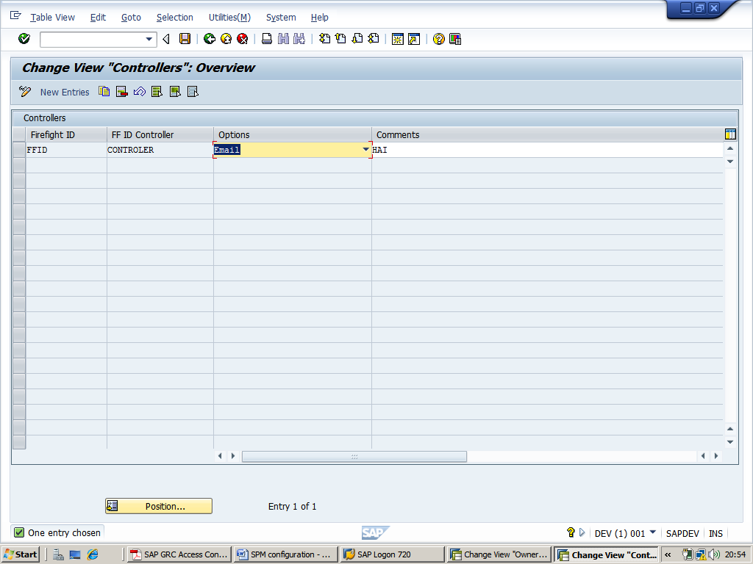

Logon as Firefighter and start transaction /VIRSA/VFAT

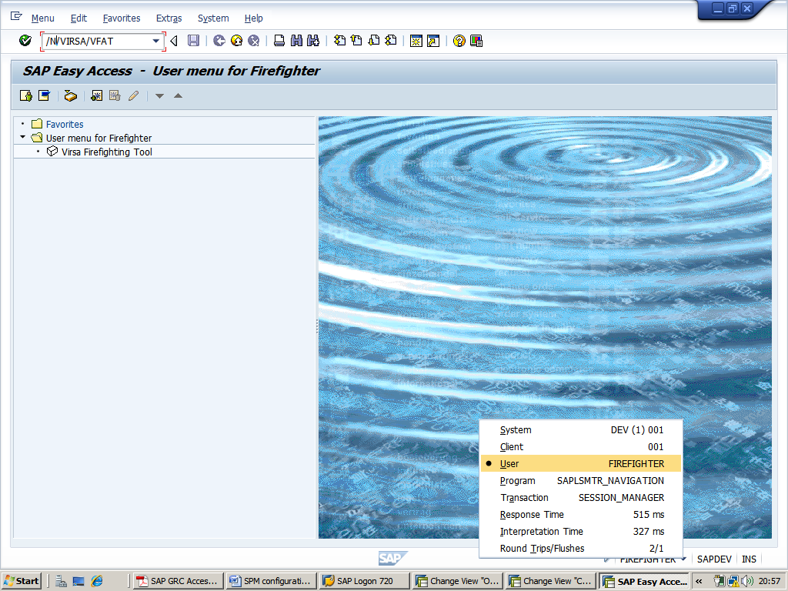

After hit the transection /N/VIRSA/VFAT the status is green(As long as the status is green the Firefighter ID is not in use and you can logon with it.)

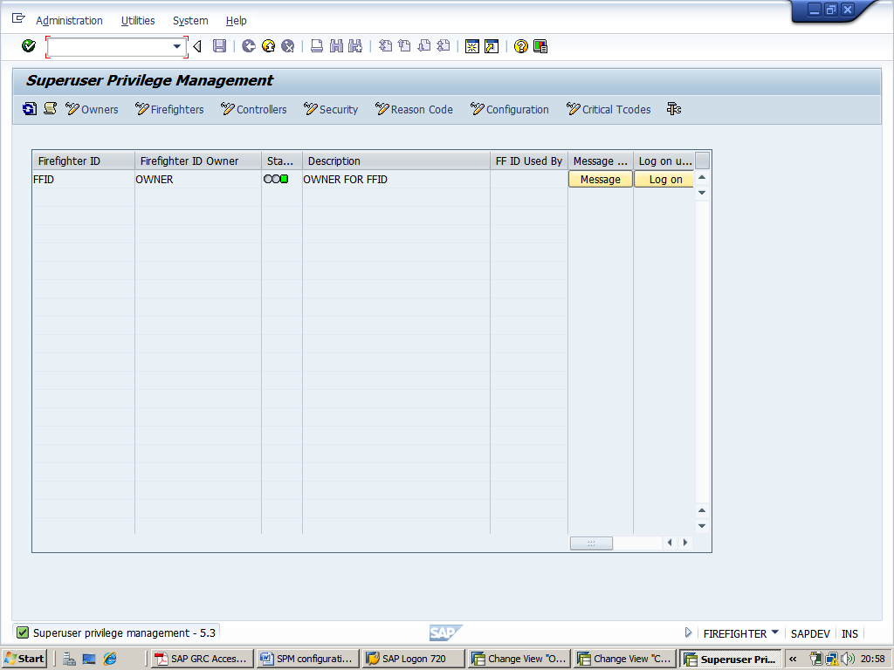

Click on Logon button-->then click continue

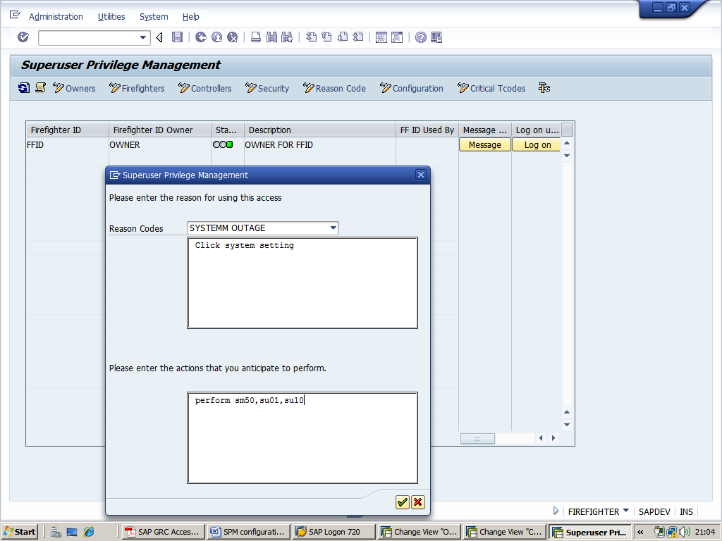

Note that the status has turned red. This means that the Firefighter ID is not available for no one else as of this point in time.
